|  |
| --- |
| Final Project SAS – CRM  Report |
| METRO COLLEGE OF TECHNOLOGY - DATA SCIENCE AND APPLICATION |
| ANA CLARA TUPINAMBÁ FREITAS, mentored by Professor HAMID RAJAEE |
| Presented at 22nd of July, 2021 |

|  |
| --- |
| Today’s marketplace demands that businesses reduce customer turnover. This project analyses 2 years' worth of customers data of a telecommunications company with the goal of getting insights into customer’s behaviours and identify which features are key to design the best marketing strategy. |

The CONTENTS Procedure

|  |  |  |  |
| --- | --- | --- | --- |
| Data Set Name | PERM.CRM | Observations | 102255 |
| Member Type | DATA | **Variables** | 10 |
| Engine | V9 | **Indexes** | 0 |
| Created | 07/22/2021 08:57:51 | **Observation Length** | 72 |
| Last Modified | 07/22/2021 08:57:51 | **Deleted Observations** | 0 |
| Protection |  | **Compressed** | NO |
| Data Set Type |  | **Sorted** | NO |
| Label |  |  |  |
| Data Representation | WINDOWS_64 |  |  |
| Encoding | wlatin1 Western (Windows) |  |  |

|  |  |
| --- | --- |
| Engine/Host Dependent Information | |
| Data Set Page Size | 65536 |
| Number of Data Set Pages | 113 |
| First Data Page | 1 |
| Max Obs per Page | 908 |
| Obs in First Data Page | 878 |
| Number of Data Set Repairs | 0 |
| ExtendObsCounter | YES |
| Filename | D:\1_Metro College\Courses\Advanced SAS\Project\Data\crm.sas7bdat |
| Release Created | 9.0401M7 |
| Host Created | X64_10PRO |
| Owner Name | ANACTF-1608\anacl |
| File Size | 7MB |
| File Size (bytes) | 7471104 |

|  |  |  |  |  |  |
| --- | --- | --- | --- | --- | --- |
| Alphabetic List of Variables and Attributes | | | | | |
| # | **Variable** | **Type** | **Len** | **Format** | **Label** |
| 1 | Acctno | Char | 14 |  | A/c Number |
| 2 | Actdt | Num | 8 | MMDDYY10. | A/c Activation Date |
| 8 | Age | Num | 8 |  | Age |
| 4 | DeactReason | Char | 4 |  | Deactivation Reason |
| 3 | Deactdt | Num | 8 | MMDDYY10. | A/c Deactivation Date |
| 7 | DealerType | Char | 2 |  | Dealer Type |
| 5 | GoodCredit | Num | 8 | G_CREDIT_F. | Good Credit? |
| 9 | Province | Char | 2 |  | Province |
| 6 | RatePlan | Num | 8 |  | Rate plan |
| 10 | Sales | Num | 8 | DOLLAR8.2 | Sales Amount |

|  |  |  |  |  |  |  |  |  |  |  |
| --- | --- | --- | --- | --- | --- | --- | --- | --- | --- | --- |
| Obs | Acctno | Actdt | Deactdt | DeactReason | GoodCredit | RatePlan | DealerType | Age | Province | Sales |
| 1 | 1176913194483 | 06/20/1999 | . |  | N | 1 | A1 | 58 | BC | $128.00 |
| 2 | 1176914599423 | 10/04/1999 | 10/15/1999 | NEED | Y | 1 | A1 | 45 | AB | $72.00 |
| 3 | 1176951913656 | 07/01/2000 | . |  | N | 1 | A1 | 57 | BC | $593.00 |
| 4 | 1176954000288 | 05/30/2000 | . |  | Y | 2 | A1 | 47 | ON | $83.00 |
| 5 | 1176969186303 | 12/13/2000 | . |  | Y | 1 | C1 | 82 | BC | . |
| 102251 | 2673974127660 | 12/29/2000 | . |  | Y | 1 | A2 | 50 |  | $112.00 |
| 102252 | 2674189951308 | 01/15/2001 | . |  | Y | 2 | A1 | 40 | BC | $87.00 |
| 102253 | 2674548796918 | 01/15/2001 | . |  | Y | 1 | A1 | 16 | NS | $316.00 |
| 102254 | 2675119766018 | 01/15/2001 | . |  | Y | 2 | B1 | 76 | ON | . |
| 102255 | 2675135410256 | 01/17/2001 | . |  | Y | 1 | A1 | 46 | BC | $319.00 |

|  |
| --- |
|  |
| FIRST VIEW OF DATA SET |
|  |
| FIRST AND LAST OBSERVATIONS |

|  |
| --- |
| DATA AFTER INCLUDING SEGMENTS* |

The CONTENTS Procedure

|  |  |  |  |
| --- | --- | --- | --- |
| Data Set Name | WORK.SEG | Observations | 102255 |
| Member Type | DATA | **Variables** | 16 |
| Engine | V9 | **Indexes** | 0 |
| Created | 07/22/2021 08:57:52 | **Observation Length** | 112 |
| Last Modified | 07/22/2021 08:57:52 | **Deleted Observations** | 0 |
| Protection |  | **Compressed** | NO |
| Data Set Type |  | **Sorted** | NO |
| Label |  |  |  |
| Data Representation | WINDOWS_64 |  |  |
| Encoding | wlatin1 Western (Windows) |  |  |

|  |  |
| --- | --- |
| Engine/Host Dependent Information | |
| Data Set Page Size | 65536 |
| Number of Data Set Pages | 176 |
| First Data Page | 1 |
| Max Obs per Page | 584 |
| Obs in First Data Page | 559 |
| Number of Data Set Repairs | 0 |
| ExtendObsCounter | YES |
| Filename | C:\Users\anacl\AppData\Local\Temp\SAS Temporary Files\_TD17336_ANACTF-1608_\seg.sas7bdat |
| Release Created | 9.0401M7 |
| Host Created | X64_10PRO |
| Owner Name | ANACTF-1608\anacl |
| File Size | 11MB |
| File Size (bytes) | 11599872 |

|  |  |  |  |  |  |
| --- | --- | --- | --- | --- | --- |
| Alphabetic List of Variables and Attributes | | | | | |
| # | **Variable** | **Type** | **Len** | **Format** | **Label** |
| 12 | ACTIVE | Char | 1 |  |  |
| 14 | AGE_SEG | Num | 8 | AGE_F. |  |
| 1 | Acctno | Char | 14 |  | A/c Number |
| 2 | Actdt | Num | 8 | MMDDYY10. | A/c Activation Date |
| 9 | Age | Num | 8 |  | Age |
| 4 | DeactReason | Char | 4 |  | Deactivation Reason |
| 3 | Deactdt | Num | 8 | MMDDYY10. | A/c Deactivation Date |
| 8 | DealerType | Char | 2 |  | Dealer Type |
| 6 | GoodCredit | Num | 8 | G_CREDIT_F. | Good Credit? |
| 10 | Province | Char | 2 |  | Province |
| 7 | RatePlan | Num | 8 |  | Rate plan |
| 13 | SALES_SEG | Num | 8 | SALES_F. |  |
| 11 | Sales | Num | 8 | DOLLAR8.2 | Sales Amount |
| 15 | TENURE | Num | 8 |  | Tenure(Days) |
| 5 | TENURE_AUX | Num | 8 | MMDDYY10. |  |
| 16 | TENURE_SEG | Num | 8 | TENURE_F. |  |

|  |
| --- |
| DATA AFTER INCLUDING SEGMENTS* |

|  |  |  |  |  |  |  |  |  |  |  |  |  |  |  |  |  |
| --- | --- | --- | --- | --- | --- | --- | --- | --- | --- | --- | --- | --- | --- | --- | --- | --- |
| Obs | Acctno | Actdt | Deactdt | DeactReason | TENURE_AUX | GoodCredit | RatePlan | DealerType | Age | Province | Sales | ACTIVE | SALES_SEG | AGE_SEG | TENURE | TENURE_SEG |
| 1 | 1176913194483 | 06/20/1999 | . |  | 01/21/2001 | N | 1 | A1 | 58 | BC | $128.00 | Y | $100 - $500 | 41 - 60 years | 581 | > 1 year |
| 2 | 1176914599423 | 10/04/1999 | 10/15/1999 | NEED | 10/15/1999 | Y | 1 | A1 | 45 | AB | $72.00 | N | < $100 | 41 - 60 years | 11 | 30 days |
| 3 | 1176951913656 | 07/01/2000 | . |  | 01/21/2001 | N | 1 | A1 | 57 | BC | $593.00 | Y | $500 - $800 | 41 - 60 years | 204 | 61 - 365 days |
| 4 | 1176954000288 | 05/30/2000 | . |  | 01/21/2001 | Y | 2 | A1 | 47 | ON | $83.00 | Y | < $100 | 41 - 60 years | 236 | 61 - 365 days |
| 5 | 1176969186303 | 12/13/2000 | . |  | 01/21/2001 | Y | 1 | C1 | 82 | BC | . | Y | Missing | > 60 years | 39 | 31 - 60 days |

|  |  |  |  |  |  |  |  |  |  |  |  |  |  |  |  |  |
| --- | --- | --- | --- | --- | --- | --- | --- | --- | --- | --- | --- | --- | --- | --- | --- | --- |
| Obs | Acctno | Actdt | Deactdt | DeactReason | TENURE_AUX | GoodCredit | RatePlan | DealerType | Age | Province | Sales | ACTIVE | SALES_SEG | AGE_SEG | TENURE | TENURE_SEG |
| 102251 | 2673974127660 | 12/29/2000 | . |  | 01/21/2001 | Y | 1 | A2 | 50 |  | $112.00 | Y | $100 - $500 | 41 - 60 years | 23 | 30 days |
| 102252 | 2674189951308 | 01/15/2001 | . |  | 01/21/2001 | Y | 2 | A1 | 40 | BC | $87.00 | Y | < $100 | 21 - 40 years | 6 | 30 days |
| 102253 | 2674548796918 | 01/15/2001 | . |  | 01/21/2001 | Y | 1 | A1 | 16 | NS | $316.00 | Y | $100 - $500 | <20 years | 6 | 30 days |
| 102254 | 2675119766018 | 01/15/2001 | . |  | 01/21/2001 | Y | 2 | B1 | 76 | ON | . | Y | Missing | > 60 years | 6 | 30 days |
| 102255 | 2675135410256 | 01/17/2001 | . |  | 01/21/2001 | Y | 1 | A1 | 46 | BC | $319.00 | Y | $100 - $500 | 41 - 60 years | 4 | 30 days |

*FIRST AND LAST OBSERVATIONS

|  |
| --- |
| EXPLORATORY DATA ANALYSIS(EDA) |
| Account Number |
| DUPLICATES? |

|  |  |  |
| --- | --- | --- |
| TOTAL # ACCOUNTS | TOTAL # DISTINCT ACCOUNTS | DUPLICATES? |
| 102255 | 102255 | There's no duplicates in data set. |

|  |
| --- |
| ANALYSIS OF ACTDT |
|  |

|  |  |  |
| --- | --- | --- |
| Obs | MIN | MAX |
| 1 | 01/20/1999 | 01/20/2001 |

|  |
| --- |
| FREQUENCY OF ACTDT*( FIRST 10 OBSERVATIONS) |

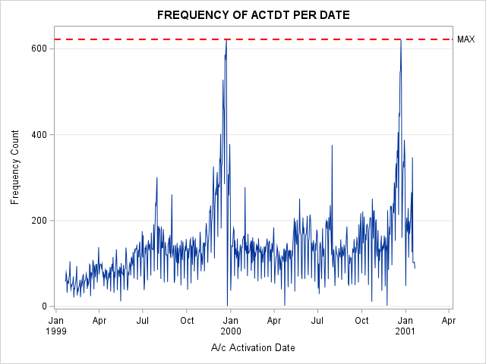

|  |  |  |
| --- | --- | --- |
| Obs | Actdt | COUNT |
| 1 | 01/20/1999 | 58 |
| 2 | 01/21/1999 | 61 |
| 3 | 01/22/1999 | 79 |
| 4 | 01/23/1999 | 72 |
| 5 | 01/24/1999 | 32 |
| 6 | 01/25/1999 | 59 |
| 7 | 01/26/1999 | 55 |
| 8 | 01/27/1999 | 54 |
| 9 | 01/28/1999 | 69 |
| 10 | 01/29/1999 | 74 |

|  |
| --- |
| DAY WITH MOST # |

|  |  |
| --- | --- |
| A/c Activation Date | Frequency Count |
| 12/23/1999 | 622 |

|  |
| --- |
| ANALYSIS OF DEACTDT |
| MINIMUM AND MAXIMUM DEACTDT DATES |

|  |  |  |
| --- | --- | --- |
| Obs | MIN | MAX |
| 1 | 01/25/1999 | 01/20/2001 |

|  |
| --- |
| FREQUENCY OF DEACTDT (FIRST 10 OBSERVATIONS) |

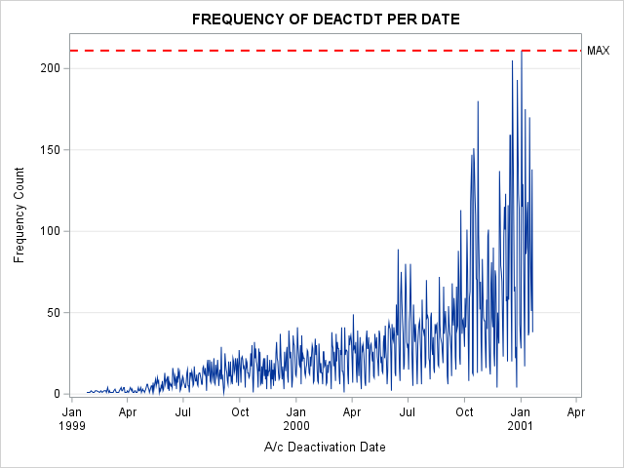

|  |  |  |
| --- | --- | --- |
| Obs | Deactdt | COUNT |
| 1 | 01/25/1999 | 1 |
| 2 | 01/30/1999 | 1 |
| 3 | 02/01/1999 | 2 |
| 4 | 02/04/1999 | 1 |
| 5 | 02/06/1999 | 1 |
| 6 | 02/08/1999 | 2 |
| 7 | 02/10/1999 | 2 |
| 8 | 02/15/1999 | 1 |
| 9 | 02/17/1999 | 2 |
| 10 | 02/19/1999 | 1 |

|  |
| --- |
| DAY WITH MOST # |

|  |  |
| --- | --- |
| A/c Deactivation Date | Frequency Count |
| 01/02/2001 | 211 |

|  |
| --- |
| ACTIVE VS DEACTIVE # ACCOUNTS PER DATE |

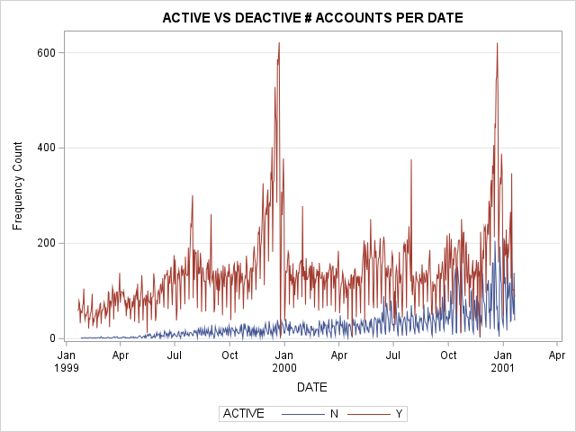

|  |  |  |  |
| --- | --- | --- | --- |
| Obs | DATE | ACTIVE | COUNT |
| 1 | 01/25/1999 | N | 1 |
| 2 | 01/30/1999 | N | 1 |
| 3 | 02/01/1999 | N | 2 |
| 4 | 02/04/1999 | N | 1 |
| 5 | 02/06/1999 | N | 1 |
| 6 | 02/08/1999 | N | 2 |
| 7 | 02/10/1999 | N | 2 |
| 8 | 02/15/1999 | N | 1 |
| 9 | 02/17/1999 | N | 2 |
| 10 | 02/19/1999 | N | 1 |

*10 FIRST OBSERVATIONS

|  |
| --- |
| **UNIVARIATE ANALYSIS** |

|  |
| --- |
| UNIVARIATE ANALYSIS OF DeactReason FOR SEG |

The FREQ Procedure

|  |  |  |  |  |
| --- | --- | --- | --- | --- |
| Number of Variable Levels | | | | |
| Variable | **Label** | **Levels** | **Missing Levels** | **Nonmissing Levels** |
| DeactReason | Deactivation Reason | 6 | 1 | 5 |

|  |  |  |  |  |
| --- | --- | --- | --- | --- |
| Deactivation Reason | | | | |
| DeactReason | **Frequency** | **Percent** | **Cumulative Frequency** | **Cumulative Percent** |
|  | 83162 | 81.33 | 83162 | 81.33 |
| COMP | 4722 | 4.62 | 87884 | 85.95 |
| DEBT | 4020 | 3.93 | 91904 | 89.88 |
| MOVE | 1696 | 1.66 | 93600 | 91.54 |
| NEED | 6888 | 6.74 | 100488 | 98.27 |
| TECH | 1767 | 1.73 | 102255 | 100.00 |

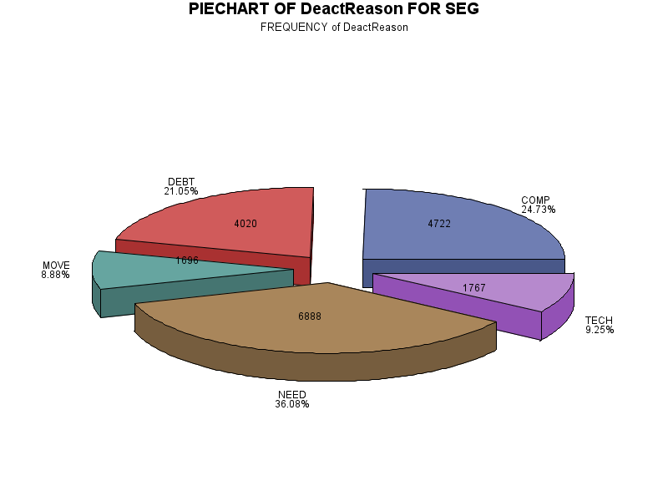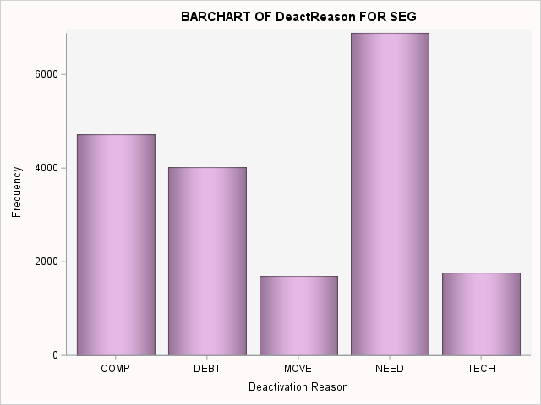

|  |
| --- |
| UNIVARIATE ANALYSIS OF GoodCredit FOR SEG |

The FREQ Procedure

|  |  |  |
| --- | --- | --- |
| Number of Variable Levels | | |
| Variable | **Label** | **Levels** |
| GoodCredit | Good Credit? | 2 |

|  |  |  |  |  |
| --- | --- | --- | --- | --- |
| Good Credit? | | | | |
| GoodCredit | **Frequency** | **Percent** | **Cumulative Frequency** | **Cumulative Percent** |
| N | 31253 | 30.56 | 31253 | 30.56 |
| Y | 71002 | 69.44 | 102255 | 100.00 |

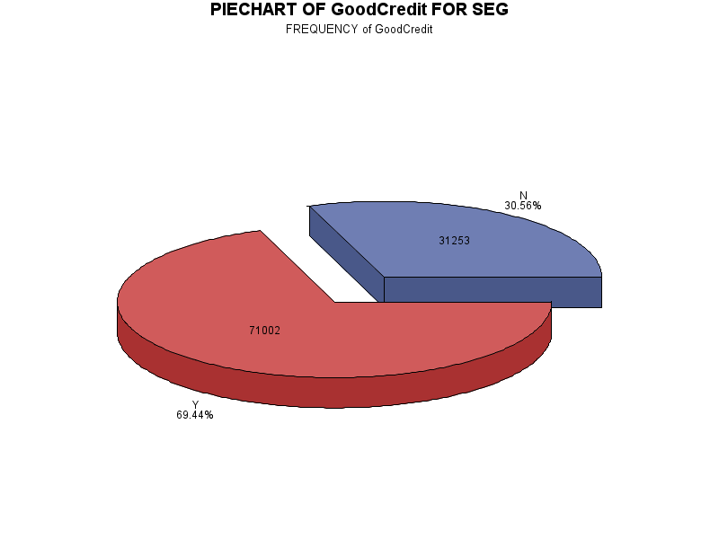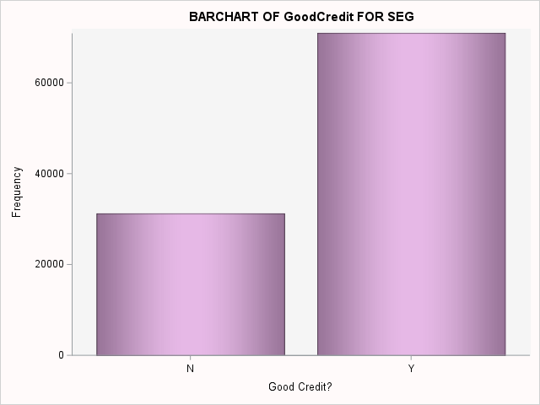

|  |
| --- |
| UNIVARIATE ANALYSIS OF RatePlan FOR SEG |

The FREQ Procedure

|  |  |  |
| --- | --- | --- |
| Number of Variable Levels | | |
| Variable | **Label** | **Levels** |
| RatePlan | Rate plan | 3 |

|  |  |  |  |  |
| --- | --- | --- | --- | --- |
| Rate plan | | | | |
| RatePlan | **Frequency** | **Percent** | **Cumulative Frequency** | **Cumulative Percent** |
| 1 | 68194 | 66.69 | 68194 | 66.69 |
| 2 | 20187 | 19.74 | 88381 | 86.43 |
| 3 | 13874 | 13.57 | 102255 | 100.00 |

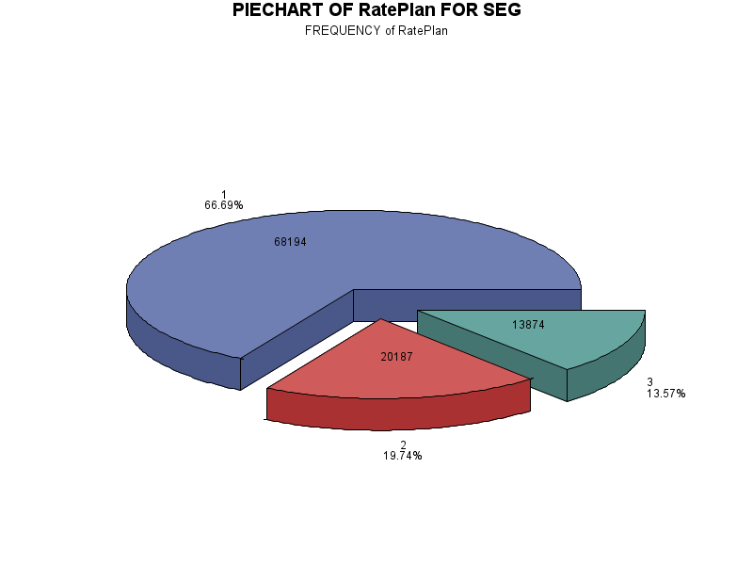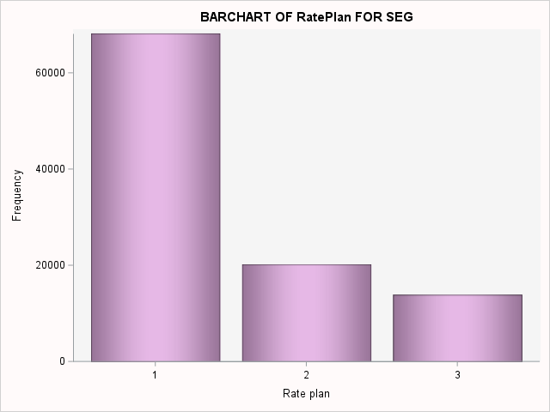

|  |
| --- |
| UNIVARIATE ANALYSIS OF DealerType FOR SEG |

The FREQ Procedure

|  |  |  |
| --- | --- | --- |
| Number of Variable Levels | | |
| Variable | **Label** | **Levels** |
| DealerType | Dealer Type | 4 |

|  |  |  |  |  |
| --- | --- | --- | --- | --- |
| Dealer Type | | | | |
| DealerType | **Frequency** | **Percent** | **Cumulative Frequency** | **Cumulative Percent** |
| A1 | 56132 | 54.89 | 56132 | 54.89 |
| A2 | 11255 | 11.01 | 67387 | 65.90 |
| B1 | 20670 | 20.21 | 88057 | 86.12 |
| C1 | 14198 | 13.88 | 102255 | 100.00 |

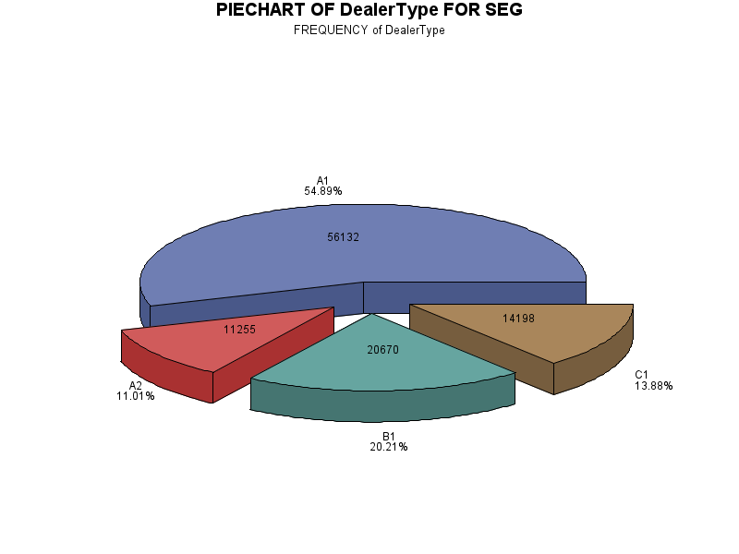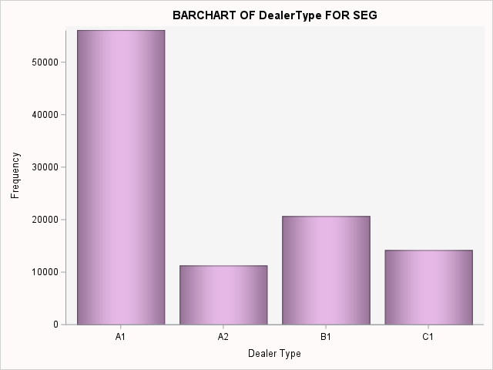

|  |
| --- |
| UNIVARIATE ANALYSIS OF Province FOR SEG |

The FREQ Procedure

|  |  |  |  |  |
| --- | --- | --- | --- | --- |
| Number of Variable Levels | | | | |
| Variable | **Label** | **Levels** | **Missing Levels** | **Nonmissing Levels** |
| Province | Province | 6 | 1 | 5 |

|  |  |  |  |  |
| --- | --- | --- | --- | --- |
| Province | | | | |
| Province | **Frequency** | **Percent** | **Cumulative Frequency** | **Cumulative Percent** |
|  | 5907 | 5.78 | 5907 | 5.78 |
| AB | 10277 | 10.05 | 16184 | 15.83 |
| BC | 22040 | 21.55 | 38224 | 37.38 |
| NS | 11529 | 11.27 | 49753 | 48.66 |
| ON | 42500 | 41.56 | 92253 | 90.22 |
| QC | 10002 | 9.78 | 102255 | 100.00 |

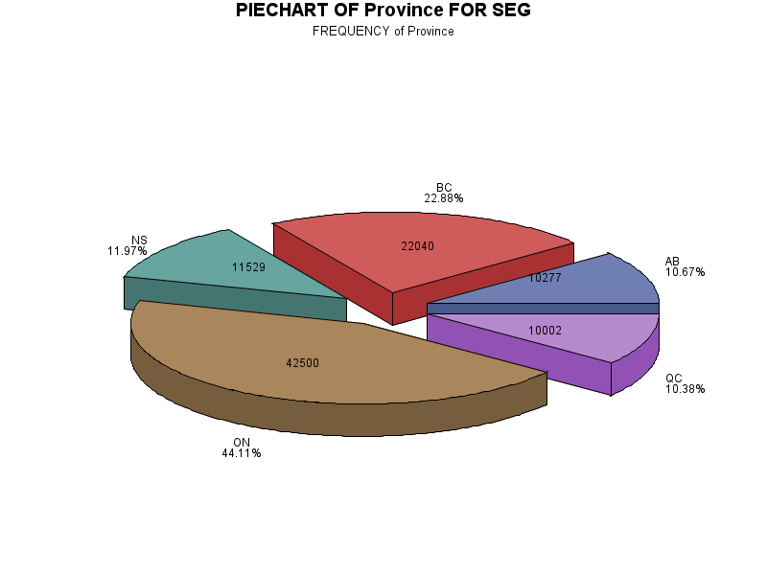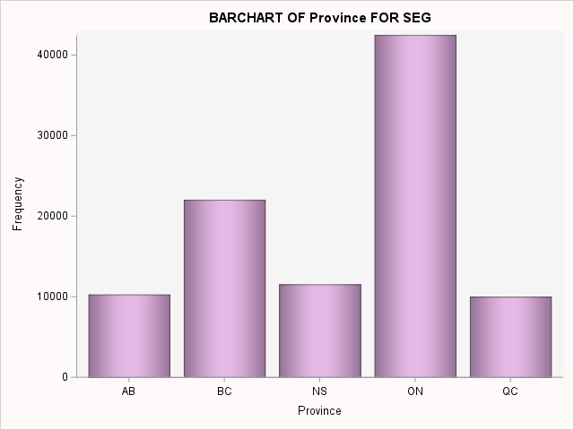

|  |
| --- |
| UNIVARIATE ANALYSIS OF TENURE_SEG FOR SEG |

The FREQ Procedure

|  |  |
| --- | --- |
| Number of Variable Levels | |
| Variable | **Levels** |
| TENURE_SEG | 4 |

|  |  |  |  |  |
| --- | --- | --- | --- | --- |
| TENURE_SEG | Frequency | Percent | Cumulative Frequency | Cumulative Percent |
| 30 days | 9566 | 9.36 | 9566 | 9.36 |
| 31 - 60 days | 8534 | 8.35 | 18100 | 17.70 |
| 61 - 365 days | 45404 | 44.40 | 63504 | 62.10 |
| > 1 year | 38751 | 37.90 | 102255 | 100.00 |

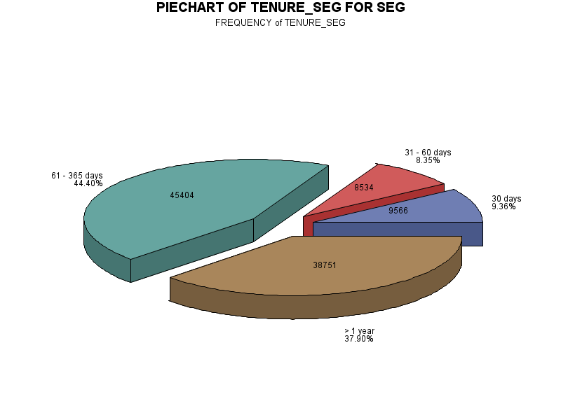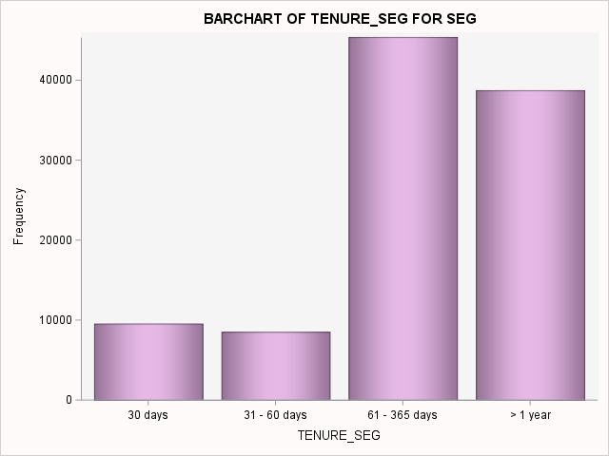

|  |
| --- |
| UNIVARIATE ANALYSIS OF AGE_SEG FOR SEG |

The FREQ Procedure

|  |  |  |  |
| --- | --- | --- | --- |
| Number of Variable Levels | | | |
| Variable | **Levels** | **Missing Levels** | **Nonmissing Levels** |
| AGE_SEG | 5 | 1 | 4 |

|  |  |  |  |  |
| --- | --- | --- | --- | --- |
| AGE_SEG | Frequency | Percent | Cumulative Frequency | Cumulative Percent |
| Missing | 9231 | 9.03 | 9231 | 9.03 |
| <20 years | 5666 | 5.54 | 14897 | 14.57 |
| 21 - 40 years | 26382 | 25.80 | 41279 | 40.37 |
| 41 - 60 years | 37478 | 36.65 | 78757 | 77.02 |
| > 60 years | 23498 | 22.98 | 102255 | 100.00 |

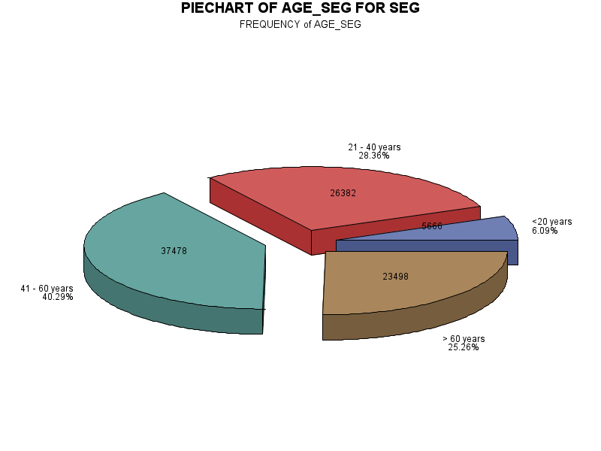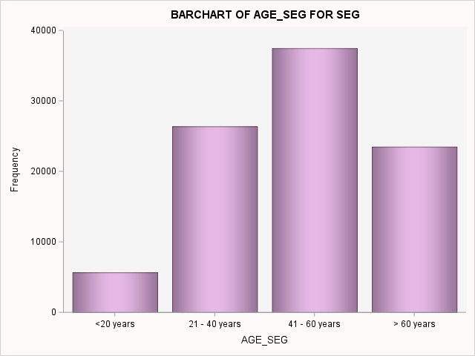

|  |
| --- |
| UNIVARIATE ANALYSIS OF SALES_SEG FOR SEG |

The FREQ Procedure

|  |  |  |  |
| --- | --- | --- | --- |
| Number of Variable Levels | | | |
| Variable | **Levels** | **Missing Levels** | **Nonmissing Levels** |
| SALES_SEG | 5 | 1 | 4 |

|  |  |  |  |  |
| --- | --- | --- | --- | --- |
| SALES_SEG | Frequency | Percent | Cumulative Frequency | Cumulative Percent |
| Missing | 8605 | 8.42 | 8605 | 8.42 |
| < $100 | 52376 | 51.22 | 60981 | 59.64 |
| $100 - $500 | 32100 | 31.39 | 93081 | 91.03 |
| $500 - $800 | 4933 | 4.82 | 98014 | 95.85 |
| > $800 | 4241 | 4.15 | 102255 | 100.00 |

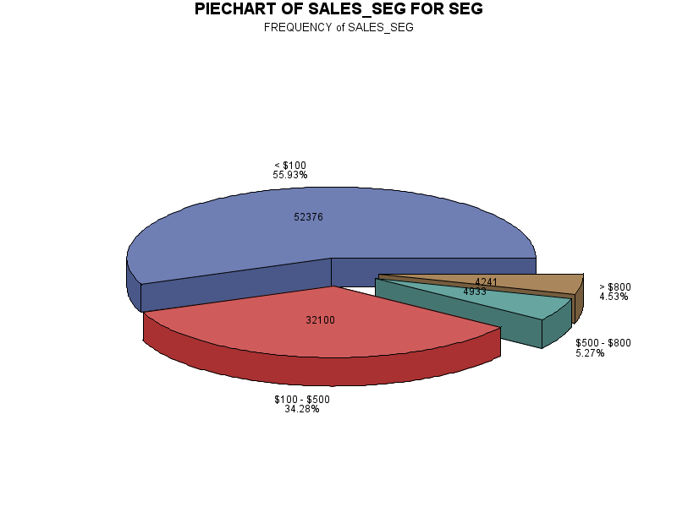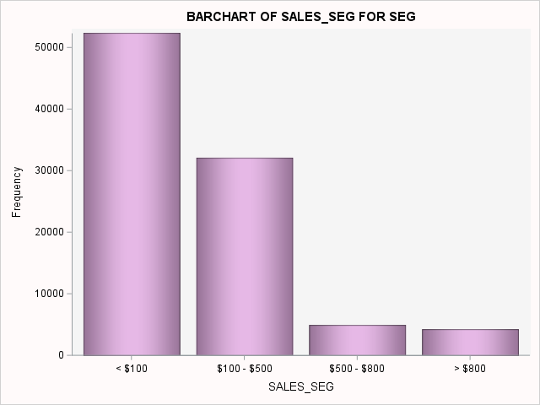

|  |
| --- |
| TENURE |

The MEANS Procedure

|  |  |  |  |  |  |  |  |  |  |  |
| --- | --- | --- | --- | --- | --- | --- | --- | --- | --- | --- |
| Analysis Variable : TENURE Tenure(Days) | | | | | | | | | | |
| N | **N Miss** | **Mean** | **Median** | **Mode** | **Minimum** | **Maximum** | **Std Dev** | **Variance** | **Range** | **Quartile Range** |
| 102255 | 0 | 283.38 | 266.00 | 30.00 | 0.00 | 732.00 | 197.39 | 38963.98 | 732.00 | 324.00 |

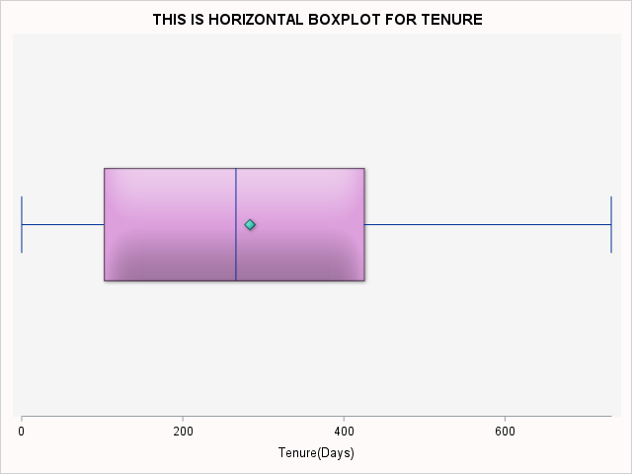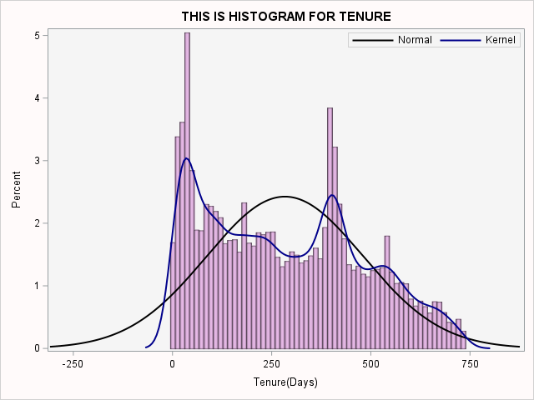

*The base date for calculation of tenure is: 21Jan2001

|  |
| --- |
| Sales |

The MEANS Procedure

|  |  |  |  |  |  |  |  |  |  |  |
| --- | --- | --- | --- | --- | --- | --- | --- | --- | --- | --- |
| Analysis Variable : Sales Sales Amount | | | | | | | | | | |
| N | **N Miss** | **Mean** | **Median** | **Mode** | **Minimum** | **Maximum** | **Std Dev** | **Variance** | **Range** | **Quartile Range** |
| 93650 | 8605 | 181.25 | 91.00 | 92.00 | 0.00 | 1200.00 | 233.97 | 54742.45 | 1200.00 | 138.00 |

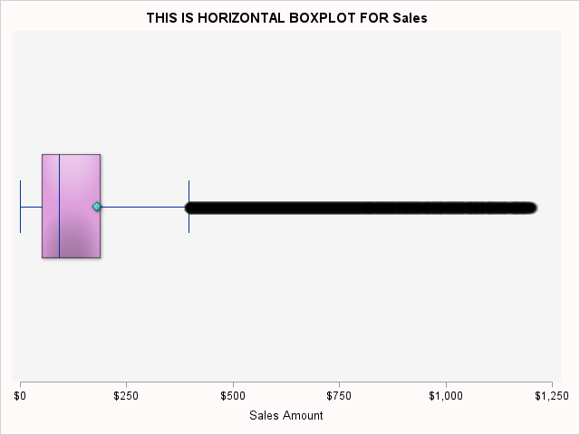

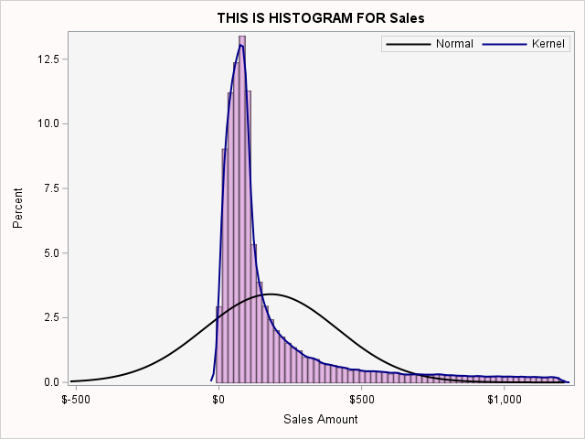

|  |
| --- |
| THIS IS HISTOGRAM FOR Age |

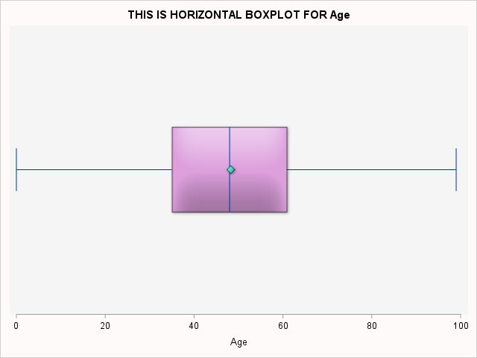The MEANS Procedure

|  |  |  |  |  |  |  |  |  |  |  |
| --- | --- | --- | --- | --- | --- | --- | --- | --- | --- | --- |
| Analysis Variable : Age Age | | | | | | | | | | |
| N | **N Miss** | **Mean** | **Median** | **Mode** | **Minimum** | **Maximum** | **Std Dev** | **Variance** | **Range** | **Quartile Range** |
| 93024 | 9231 | 48.28 | 48.00 | 48.00 | 0.00 | 99.00 | 17.91 | 320.86 | 99.00 | 26.00 |
|  |  |  |  |  |  |  |  |  |  |  |

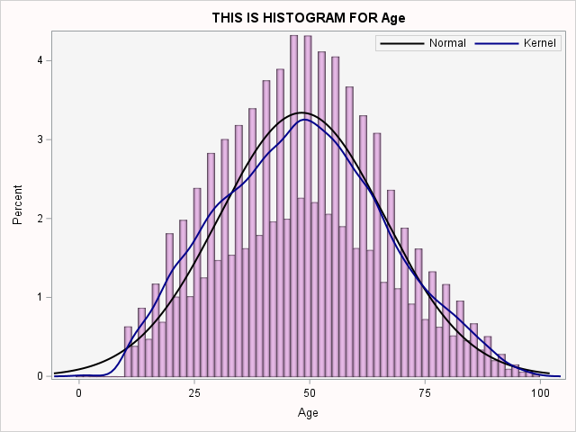

|  |
| --- |
| DROPPING OBSERVATIONS |

|  |
| --- |
| We can see age as low as 0, since the goal of this analysis is to investigate customers' distribution and behaviours,I'll drop any observations with the age of 18, the usually legal age.It was decided that since this is a behavioural study to trimm observations below the legal age and missing provinces and missing sales.Keeping even then 75% of abservations. |

|  |
| --- |
| PERCENTAGE OF PRESERVED DATA |

|  |  |  |  |  |
| --- | --- | --- | --- | --- |
| Obs | id | Total_obs_BEFORE_dropping | Total_obs_AFTER_dropping | PERC |
| 1 | 1 | 102255 | 76877 | 75% |

|  |
| --- |
| UNIVARIATE ANALYSIS - After Trimming observations |

|  |
| --- |
| UNIVARIATE ANALYSIS OF DeactReason FOR SEG |

The FREQ Procedure

|  |  |  |  |  |
| --- | --- | --- | --- | --- |
| Number of Variable Levels | | | | |
| Variable | **Label** | **Levels** | **Missing Levels** | **Nonmissing Levels** |
| DeactReason | Deactivation Reason | 6 | 1 | 5 |

|  |  |  |  |  |
| --- | --- | --- | --- | --- |
| Deactivation Reason | | | | |
| DeactReason | **Frequency** | **Percent** | **Cumulative Frequency** | **Cumulative Percent** |
|  | 62474 | 81.26 | 62474 | 81.26 |
| COMP | 3541 | 4.61 | 66015 | 85.87 |
| DEBT | 2992 | 3.89 | 69007 | 89.76 |
| MOVE | 1279 | 1.66 | 70286 | 91.43 |
| NEED | 5272 | 6.86 | 75558 | 98.28 |
| TECH | 1319 | 1.72 | 76877 | 100.00 |

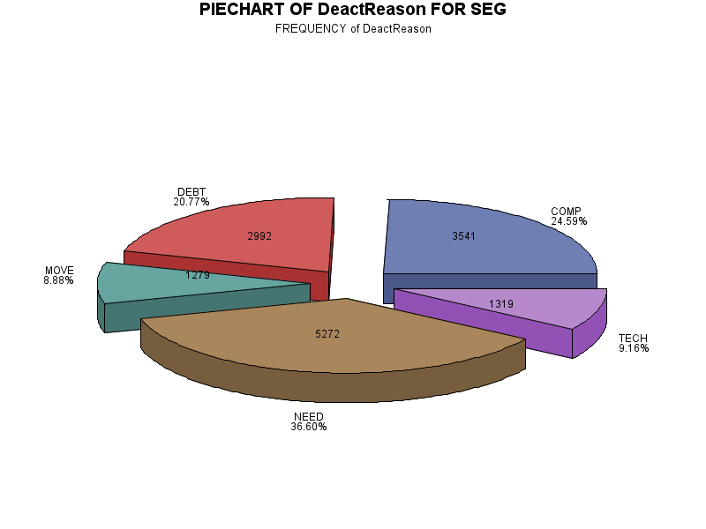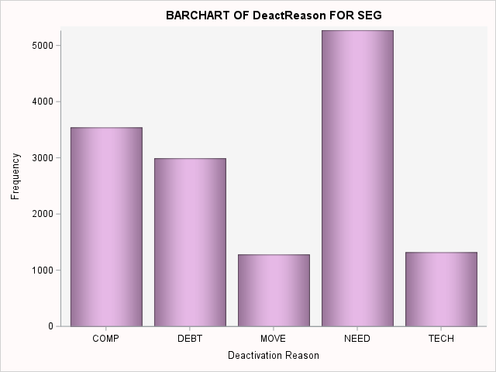

|  |
| --- |
| UNIVARIATE ANALYSIS OF GoodCredit FOR SEG |

The FREQ Procedure

|  |  |  |
| --- | --- | --- |
| Number of Variable Levels | | |
| Variable | **Label** | **Levels** |
| GoodCredit | Good Credit? | 2 |

|  |  |  |  |  |
| --- | --- | --- | --- | --- |
| Good Credit? | | | | |
| GoodCredit | **Frequency** | **Percent** | **Cumulative Frequency** | **Cumulative Percent** |
| N | 23441 | 30.49 | 23441 | 30.49 |
| Y | 53436 | 69.51 | 76877 | 100.00 |

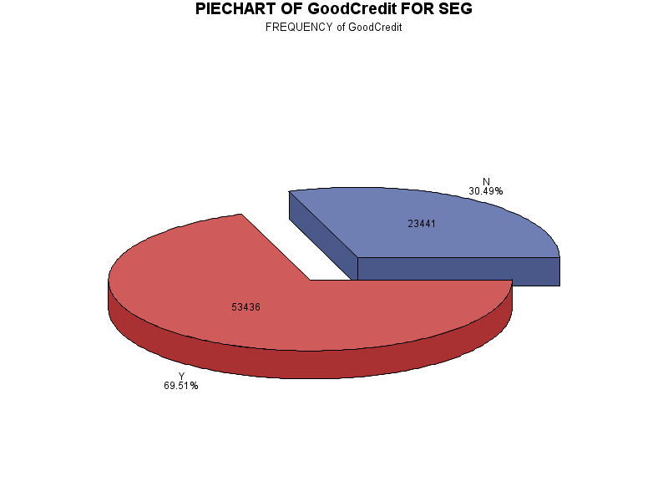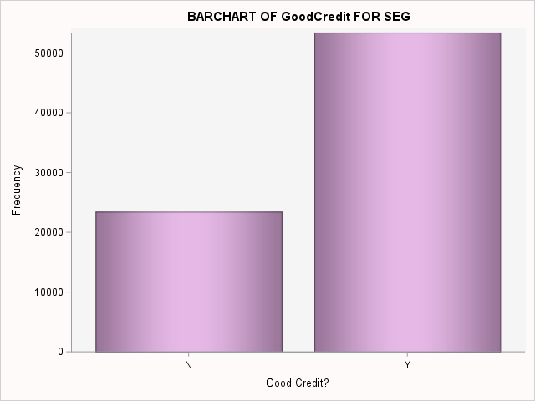

|  |
| --- |
| UNIVARIATE ANALYSIS OF RatePlan FOR SEG |

The FREQ Procedure

|  |  |  |
| --- | --- | --- |
| Number of Variable Levels | | |
| Variable | **Label** | **Levels** |
| RatePlan | Rate plan | 3 |

|  |  |  |  |  |
| --- | --- | --- | --- | --- |
| Rate plan | | | | |
| RatePlan | **Frequency** | **Percent** | **Cumulative Frequency** | **Cumulative Percent** |
| 1 | 51284 | 66.71 | 51284 | 66.71 |
| 2 | 15254 | 19.84 | 66538 | 86.55 |
| 3 | 10339 | 13.45 | 76877 | 100.00 |

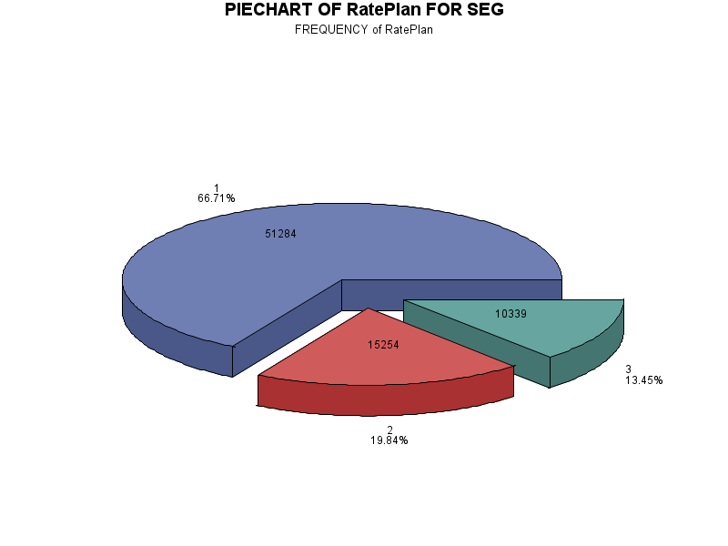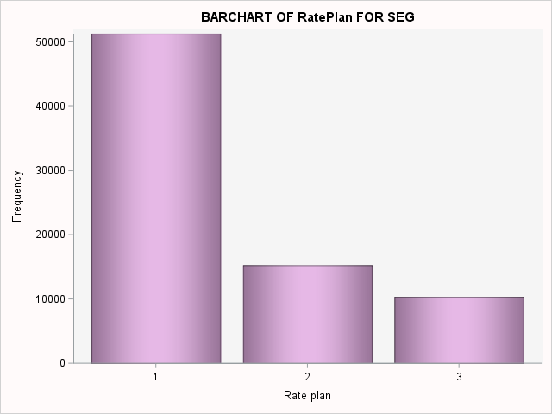

|  |
| --- |
| UNIVARIATE ANALYSIS OF DealerType FOR SEG |

The FREQ Procedure

|  |  |  |
| --- | --- | --- |
| Number of Variable Levels | | |
| Variable | **Label** | **Levels** |
| DealerType | Dealer Type | 4 |

|  |  |  |  |  |
| --- | --- | --- | --- | --- |
| Dealer Type | | | | |
| DealerType | **Frequency** | **Percent** | **Cumulative Frequency** | **Cumulative Percent** |
| A1 | 42160 | 54.84 | 42160 | 54.84 |
| A2 | 8430 | 10.97 | 50590 | 65.81 |
| B1 | 15503 | 20.17 | 66093 | 85.97 |
| C1 | 10784 | 14.03 | 76877 | 100.00 |

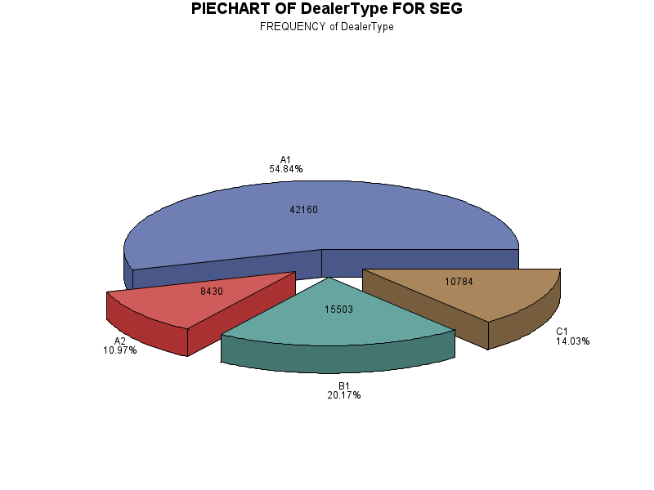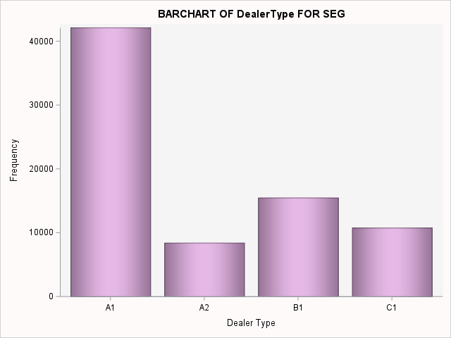

|  |
| --- |
| UNIVARIATE ANALYSIS OF Province FOR SEG |

The FREQ Procedure

|  |  |  |
| --- | --- | --- |
| Number of Variable Levels | | |
| Variable | **Label** | **Levels** |
| Province | Province | 5 |

|  |  |  |  |  |
| --- | --- | --- | --- | --- |
| Province | | | | |
| Province | **Frequency** | **Percent** | **Cumulative Frequency** | **Cumulative Percent** |
| AB | 8245 | 10.72 | 8245 | 10.72 |
| BC | 17567 | 22.85 | 25812 | 33.58 |
| NS | 9224 | 12.00 | 35036 | 45.57 |
| ON | 33857 | 44.04 | 68893 | 89.61 |
| QC | 7984 | 10.39 | 76877 | 100.00 |

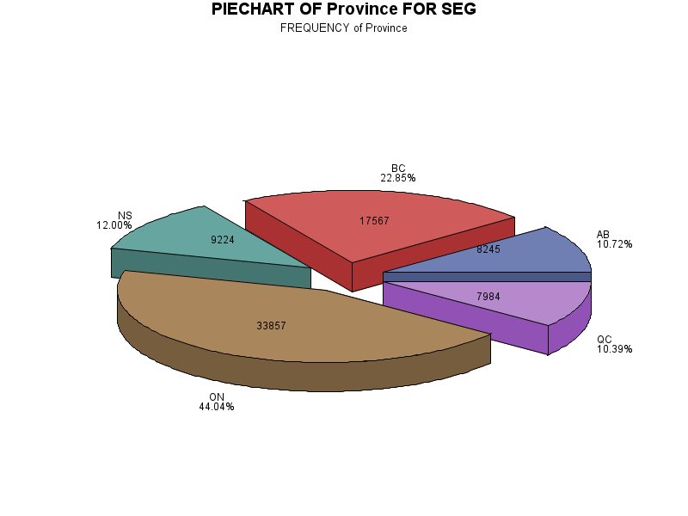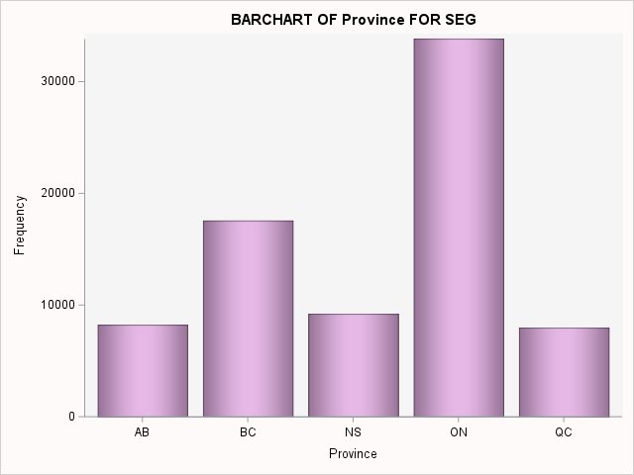

|  |
| --- |
| THIS IS HISTOGRAM FOR Age |

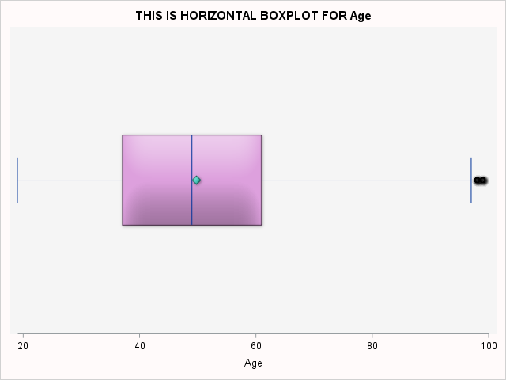The MEANS Procedure

|  |  |  |  |  |  |  |  |  |  |  |
| --- | --- | --- | --- | --- | --- | --- | --- | --- | --- | --- |
| Analysis Variable : Age Age | | | | | | | | | | |
| N | **N Miss** | **Mean** | **Median** | **Mode** | **Minimum** | **Maximum** | **Std Dev** | **Variance** | **Range** | **Quartile Range** |
| 76877 | 0 | 49.78 | 49.00 | 48.00 | 19.00 | 99.00 | 16.78 | 281.73 | 80.00 | 24.00 |

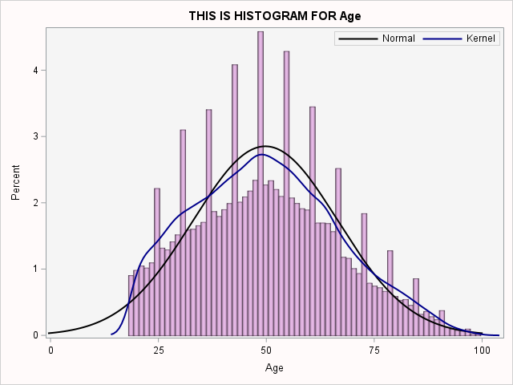

|  |
| --- |
| THIS IS HISTOGRAM FOR Sales |

The MEANS Procedure

|  |  |  |  |  |  |  |  |  |  |  |
| --- | --- | --- | --- | --- | --- | --- | --- | --- | --- | --- |
| Analysis Variable : Sales Sales Amount | | | | | | | | | | |
| N | **N Miss** | **Mean** | **Median** | **Mode** | **Minimum** | **Maximum** | **Std Dev** | **Variance** | **Range** | **Quartile Range** |
| 76877 | 0 | 181.32 | 91.00 | 94.00 | 0.00 | 1200.00 | 233.87 | 54693.34 | 1200.00 | 137.00 |

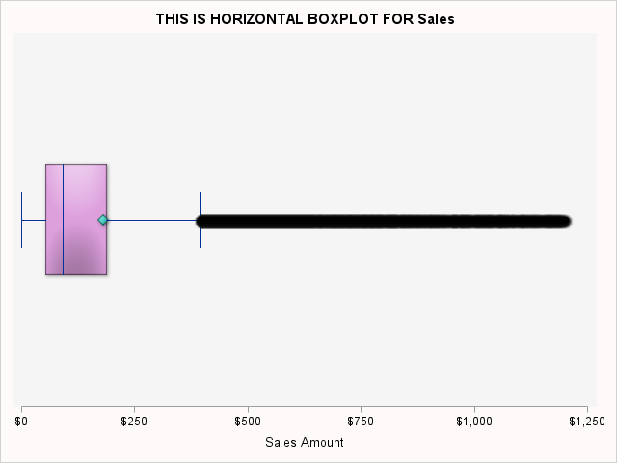

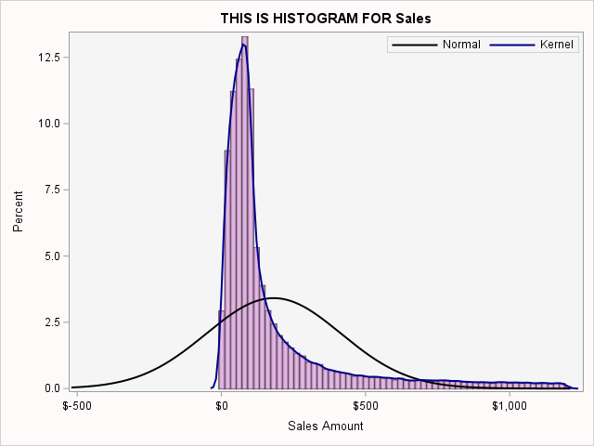

|  |
| --- |
| THIS IS HISTOGRAM FOR TENURE |

The MEANS Procedure

|  |  |  |  |  |  |  |  |  |  |  |
| --- | --- | --- | --- | --- | --- | --- | --- | --- | --- | --- |
| Analysis Variable : TENURE Tenure(Days) | | | | | | | | | | |
| N | **N Miss** | **Mean** | **Median** | **Mode** | **Minimum** | **Maximum** | **Std Dev** | **Variance** | **Range** | **Quartile Range** |
| 76877 | 0 | 282.98 | 265.00 | 30.00 | 0.00 | 732.00 | 197.64 | 39060.11 | 732.00 | 325.00 |

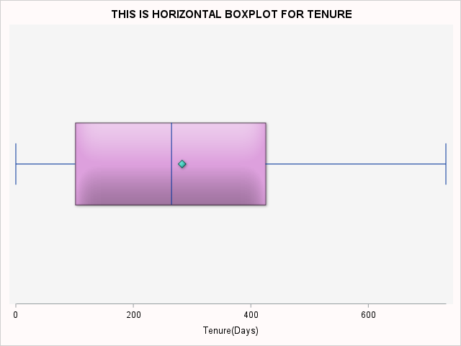

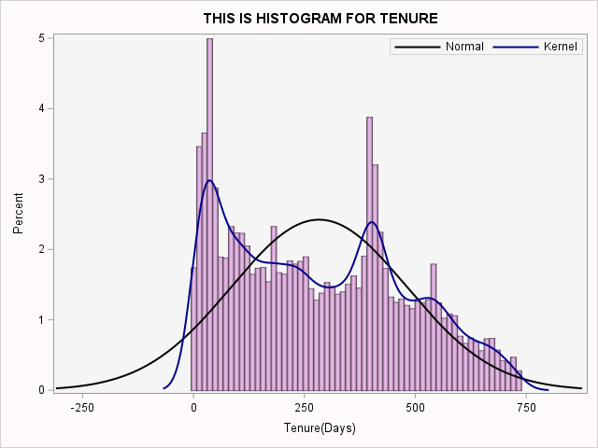

|  |
| --- |
| UNIVARIATE ANALYSIS OF TENURE_SEG FOR SEG |

The FREQ Procedure

|  |  |
| --- | --- |
| Number of Variable Levels | |
| Variable | **Levels** |
| TENURE_SEG | 4 |

|  |  |  |  |  |
| --- | --- | --- | --- | --- |
| TENURE_SEG | Frequency | Percent | Cumulative Frequency | Cumulative Percent |
| 30 days | 7315 | 9.52 | 7315 | 9.52 |
| 31 - 60 days | 6414 | 8.34 | 13729 | 17.86 |
| 61 - 365 days | 34063 | 44.31 | 47792 | 62.17 |
| > 1 year | 29085 | 37.83 | 76877 | 100.00 |

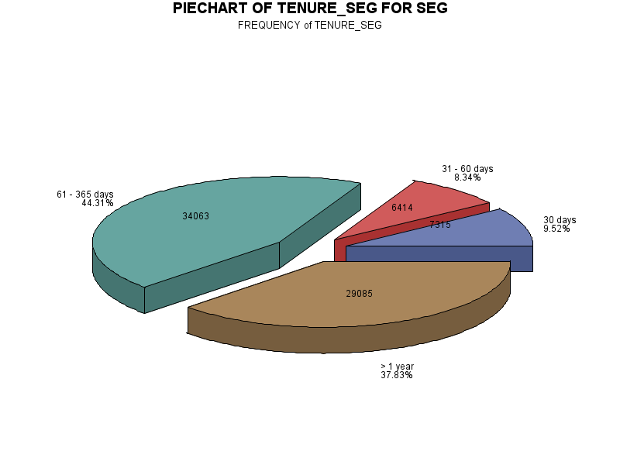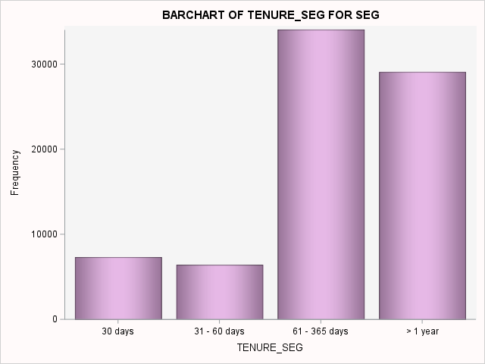

|  |
| --- |
| UNIVARIATE ANALYSIS OF AGE_SEG FOR SEG |

The FREQ Procedure

|  |  |
| --- | --- |
| Number of Variable Levels | |
| Variable | **Levels** |
| AGE_SEG | 4 |

|  |  |  |  |  |
| --- | --- | --- | --- | --- |
| AGE_SEG | Frequency | Percent | Cumulative Frequency | Cumulative Percent |
| <20 years | 1456 | 1.89 | 1456 | 1.89 |
| 21 - 40 years | 22757 | 29.60 | 24213 | 31.50 |
| 41 - 60 years | 32369 | 42.10 | 56582 | 73.60 |
| > 60 years | 20295 | 26.40 | 76877 | 100.00 |

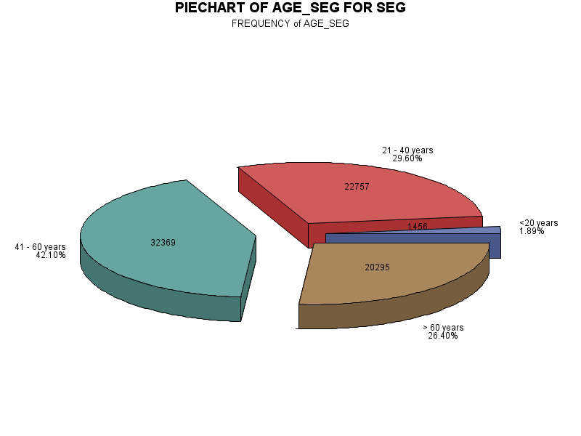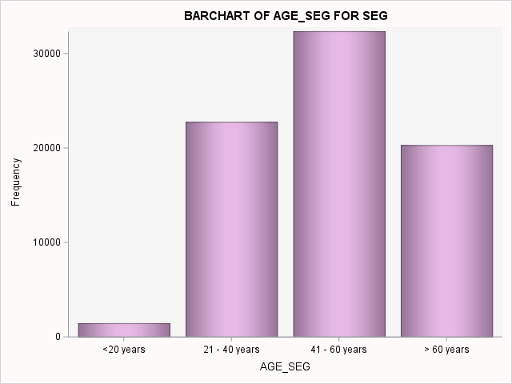

|  |
| --- |
| UNIVARIATE ANALYSIS OF SALES_SEG FOR SEG |

The FREQ Procedure

|  |  |
| --- | --- |
| Number of Variable Levels | |
| Variable | **Levels** |
| SALES_SEG | 4 |

|  |  |  |  |  |
| --- | --- | --- | --- | --- |
| SALES_SEG | Frequency | Percent | Cumulative Frequency | Cumulative Percent |
| < $100 | 42960 | 55.88 | 42960 | 55.88 |
| $100 - $500 | 26379 | 34.31 | 69339 | 90.19 |
| $500 - $800 | 4060 | 5.28 | 73399 | 95.48 |
| > $800 | 3478 | 4.52 | 76877 | 100.00 |

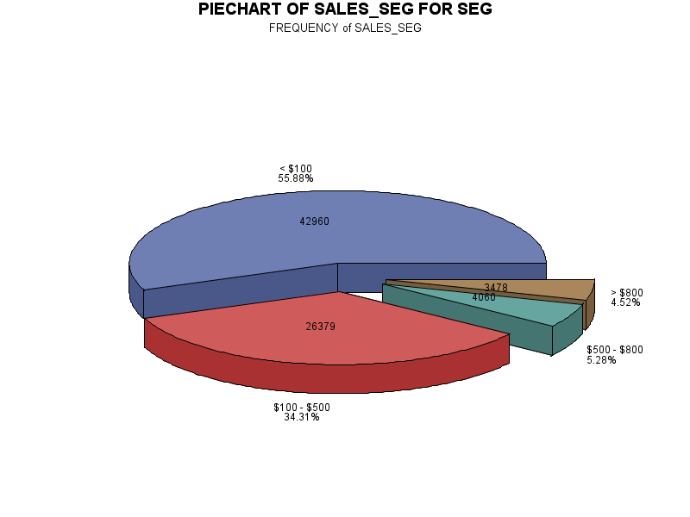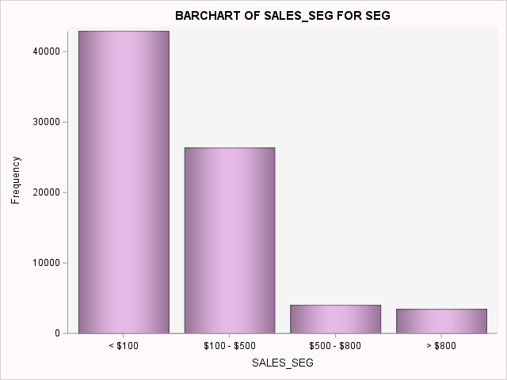

|  |
| --- |
| # OF DEACTIVED ACCOUNTS PER MONTH/YEAR |

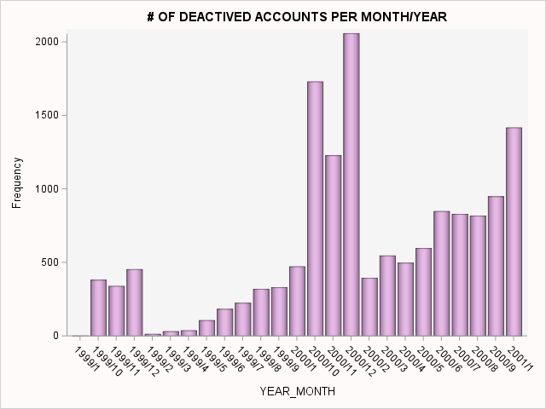

|  |  |  |
| --- | --- | --- |
| Obs | YEAR_MONTH | N_ACCOUNTS |
| 1 | 1999/1 | 2 |
| 2 | 1999/10 | 382 |
| 3 | 1999/11 | 340 |
| 4 | 1999/12 | 454 |
| 5 | 1999/2 | 14 |
| 6 | 1999/3 | 32 |
| 7 | 1999/4 | 38 |
| 8 | 1999/5 | 107 |
| 9 | 1999/6 | 184 |
| 10 | 1999/7 | 225 |
| 11 | 1999/8 | 320 |
| 12 | 1999/9 | 331 |
| 13 | 2000/1 | 473 |
| 14 | 2000/10 | 1731 |
| 15 | 2000/11 | 1229 |
| 16 | 2000/12 | 2059 |
| 17 | 2000/2 | 395 |
| 18 | 2000/3 | 547 |
| 19 | 2000/4 | 498 |
| 20 | 2000/5 | 598 |
| 21 | 2000/6 | 849 |
| 22 | 2000/7 | 830 |
| 23 | 2000/8 | 818 |
| 24 | 2000/9 | 950 |
| 25 | 2001/1 | 1418 |

|  |
| --- |
| BIVARIATE ANALYSIS |
| CATEGORICAL VS CATEGORICAL |

|  |
| --- |
| Null hypothesis: |
| 1. N, the total frequency, should be reasonably large (greater than 50) |
| 2. The sample observations should be independent. No individual item should be included twice or more in the sample" |
| 3. No expected frequencies should be small. Preferably each expected frequency should be larger than 10 but in any case not less than 5. |
|  |
| If condition of chi-square are satisfied and p-value is less than significant level (5%), reject null hypothesis: |
| - There is a relationship between them at 5% significant level. |

|  |
| --- |
| BIVARIATE ANALYSIS OF ACTIVE AND PROVINCE FOR SEG |
| Null hypothesis: ACTIVE is independent of the PROVINCE |

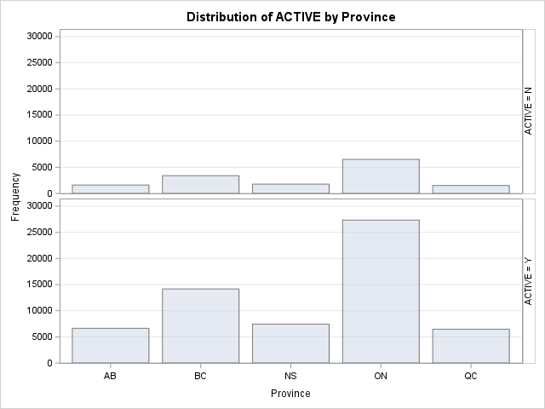The FREQ Procedure

|  |  |  |  |  |  |  |  |  |  |  |  |  |  |  |  |  |  |  |  |  |  |  |  |  |  |  |  |  |  |  |  |  |  |  |  |  |  |  |  |  |  |  |  |  |  |  |  |  |  |  |  |  |  |  |  |  |  |  |  |  |  |  |  |  |  |  |  |  |  |  |  |  |  |  |  |  |  |  |  |  |  |  |  |  |  |  |  |  |  |  |  |  |  |  |  |  |  |  |  |  |  |  |  |  |  |  |  |
| --- | --- | --- | --- | --- | --- | --- | --- | --- | --- | --- | --- | --- | --- | --- | --- | --- | --- | --- | --- | --- | --- | --- | --- | --- | --- | --- | --- | --- | --- | --- | --- | --- | --- | --- | --- | --- | --- | --- | --- | --- | --- | --- | --- | --- | --- | --- | --- | --- | --- | --- | --- | --- | --- | --- | --- | --- | --- | --- | --- | --- | --- | --- | --- | --- | --- | --- | --- | --- | --- | --- | --- | --- | --- | --- | --- | --- | --- | --- | --- | --- | --- | --- | --- | --- | --- | --- | --- | --- | --- | --- | --- | --- | --- | --- | --- | --- | --- | --- | --- | --- | --- | --- | --- | --- | --- | --- | --- |
| |  |  |  |  |  | | --- | --- | --- | --- | --- | | |  | | --- | | **Frequency** | | **Percent** | | **Row Pct** | | **Col Pct** | | | |  |  |  |  |  |  |  | | --- | --- | --- | --- | --- | --- | --- | | Table of ACTIVE by Province | | | | | | | | ACTIVE | **Province(Province)** | | | | | | | **AB** | **BC** | **NS** | **ON** | **QC** | **Total** | | N | |  | | --- | | 1611 | | 2.10 | | 10.87 | | 19.54 | | |  | | --- | | 3400 | | 4.42 | | 22.94 | | 19.35 | | |  | | --- | | 1781 | | 2.32 | | 12.01 | | 19.31 | | |  | | --- | | 6514 | | 8.47 | | 43.94 | | 19.24 | | |  | | --- | | 1518 | | 1.97 | | 10.24 | | 19.01 | | |  | | --- | | 14824 | | 19.28 | |  | |  | | | Y | |  | | --- | | 6634 | | 8.63 | | 10.69 | | 80.46 | | |  | | --- | | 14167 | | 18.43 | | 22.83 | | 80.65 | | |  | | --- | | 7443 | | 9.68 | | 11.99 | | 80.69 | | |  | | --- | | 27343 | | 35.57 | | 44.06 | | 80.76 | | |  | | --- | | 6466 | | 8.41 | | 10.42 | | 80.99 | | |  | | --- | | 62053 | | 80.72 | |  | |  | | | Total | |  | | --- | | 8245 | | 10.72 | | |  | | --- | | 17567 | | 22.85 | | |  | | --- | | 9224 | | 12.00 | | |  | | --- | | 33857 | | 44.04 | | |  | | --- | | 7984 | | 10.39 | | |  | | --- | | 76877 | | 100.00 | | |

|  |
| --- |
| **Statistics for Table of ACTIVE by Province** |

|  |  |  |  |
| --- | --- | --- | --- |
| Statistic | DF | Value | Prob |
| Chi-Square | 4 | 0.8235 | 0.9353 |
| Likelihood Ratio Chi-Square | 4 | 0.8236 | 0.9353 |
| Mantel-Haenszel Chi-Square | 1 | 0.7190 | 0.3965 |
| Phi Coefficient |  | 0.0033 |  |
| Contingency Coefficient |  | 0.0033 |  |
| Cramer's V |  | 0.0033 |  |

|  |
| --- |
| **Sample Size = 76877** |

If condition of chi-square are satisfied and p-value is less than significant level (5%),reject null hypothesis:There is a relationship between them at 5% significant level.

We can see that the assumptions for chi-square test are met, with p-value of 0.9353, we fail to reject the null hypothesis and can't say that there's a relationship between the features.

|  |
| --- |
| BIVARIATE ANALYSIS OF ACTIVE AND DEACTREASON FOR SEG1 |
| Null hypothesis: ACTIVE is independent of the DEACTREASON |

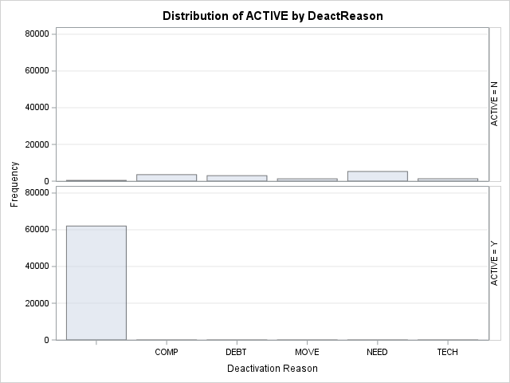The FREQ Procedure

|  |  |  |  |  |  |  |  |  |  |  |  |  |  |  |  |  |  |  |  |  |  |  |  |  |  |  |  |  |  |  |  |  |  |  |  |  |  |  |  |  |  |  |  |  |  |  |  |  |  |  |  |  |  |  |  |  |  |  |  |  |  |  |  |  |  |  |  |  |  |  |  |  |  |  |  |  |  |  |  |  |  |  |  |  |  |  |  |  |  |  |  |  |  |  |  |  |  |  |  |  |  |  |  |  |  |  |  |  |  |  |  |  |  |  |  |  |  |  |  |  |  |  |  |
| --- | --- | --- | --- | --- | --- | --- | --- | --- | --- | --- | --- | --- | --- | --- | --- | --- | --- | --- | --- | --- | --- | --- | --- | --- | --- | --- | --- | --- | --- | --- | --- | --- | --- | --- | --- | --- | --- | --- | --- | --- | --- | --- | --- | --- | --- | --- | --- | --- | --- | --- | --- | --- | --- | --- | --- | --- | --- | --- | --- | --- | --- | --- | --- | --- | --- | --- | --- | --- | --- | --- | --- | --- | --- | --- | --- | --- | --- | --- | --- | --- | --- | --- | --- | --- | --- | --- | --- | --- | --- | --- | --- | --- | --- | --- | --- | --- | --- | --- | --- | --- | --- | --- | --- | --- | --- | --- | --- | --- | --- | --- | --- | --- | --- | --- | --- | --- | --- | --- | --- | --- | --- | --- | --- |
| |  |  |  |  |  | | --- | --- | --- | --- | --- | | |  | | --- | | **Frequency** | | **Percent** | | **Row Pct** | | **Col Pct** | | | |  |  |  |  |  |  |  |  | | --- | --- | --- | --- | --- | --- | --- | --- | | Table of ACTIVE by DeactReason | | | | | | | | | ACTIVE | **DeactReason(Deactivation Reason)** | | | | | | | |  | **COMP** | **DEBT** | **MOVE** | **NEED** | **TECH** | **Total** | | N | |  | | --- | | 421 | | 0.55 | | 2.84 | | 0.67 | | |  | | --- | | 3541 | | 4.61 | | 23.89 | | 100.00 | | |  | | --- | | 2992 | | 3.89 | | 20.18 | | 100.00 | | |  | | --- | | 1279 | | 1.66 | | 8.63 | | 100.00 | | |  | | --- | | 5272 | | 6.86 | | 35.56 | | 100.00 | | |  | | --- | | 1319 | | 1.72 | | 8.90 | | 100.00 | | |  | | --- | | 14824 | | 19.28 | |  | |  | | | Y | |  | | --- | | 62053 | | 80.72 | | 100.00 | | 99.33 | | |  | | --- | | 0 | | 0.00 | | 0.00 | | 0.00 | | |  | | --- | | 0 | | 0.00 | | 0.00 | | 0.00 | | |  | | --- | | 0 | | 0.00 | | 0.00 | | 0.00 | | |  | | --- | | 0 | | 0.00 | | 0.00 | | 0.00 | | |  | | --- | | 0 | | 0.00 | | 0.00 | | 0.00 | | |  | | --- | | 62053 | | 80.72 | |  | |  | | | Total | |  | | --- | | 62474 | | 81.26 | | |  | | --- | | 3541 | | 4.61 | | |  | | --- | | 2992 | | 3.89 | | |  | | --- | | 1279 | | 1.66 | | |  | | --- | | 5272 | | 6.86 | | |  | | --- | | 1319 | | 1.72 | | |  | | --- | | 76877 | | 100.00 | | |

|  |
| --- |
| **Statistics for Table of ACTIVE by DeactReason** |

|  |  |  |  |
| --- | --- | --- | --- |
| Statistic | DF | Value | Prob |
| Chi-Square | 5 | 74190.3553 | <.0001 |
| Likelihood Ratio Chi-Square | 5 | 70336.0750 | <.0001 |
| Mantel-Haenszel Chi-Square | 1 | 57598.9003 | <.0001 |
| Phi Coefficient |  | 0.9824 |  |
| Contingency Coefficient |  | 0.7008 |  |
| Cramer's V |  | 0.9824 |  |

|  |
| --- |
| **Sample Size = 76877** |

If condition of chi-square are satisfied and p-value is less than significant level (5%),reject null hypothesis:There is a relationship between them at 5% significant level.

We can see that the assumptions for chi-square test are met, with p-value of <0.0001, we fail to reject the null hypothesis and can't say that there's a relationship between the features.

|  |
| --- |
| BIVARIATE ANALYSIS OF ACTIVE AND GOODCREDIT FOR SEG |
| Null hypothesis: ACTIVE is independent of the GOODCREDIT |

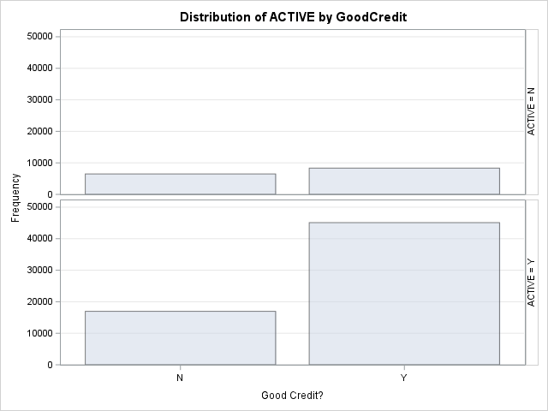The FREQ Procedure

|  |  |  |  |  |  |  |  |  |  |  |  |  |  |  |  |  |  |  |  |  |  |  |  |  |  |  |  |  |  |  |  |  |  |  |  |  |  |  |  |  |  |  |  |  |  |  |  |  |  |  |  |  |  |  |  |  |  |  |  |
| --- | --- | --- | --- | --- | --- | --- | --- | --- | --- | --- | --- | --- | --- | --- | --- | --- | --- | --- | --- | --- | --- | --- | --- | --- | --- | --- | --- | --- | --- | --- | --- | --- | --- | --- | --- | --- | --- | --- | --- | --- | --- | --- | --- | --- | --- | --- | --- | --- | --- | --- | --- | --- | --- | --- | --- | --- | --- | --- | --- |
| |  |  |  |  |  | | --- | --- | --- | --- | --- | | |  | | --- | | **Frequency** | | **Percent** | | **Row Pct** | | **Col Pct** | | | |  |  |  |  | | --- | --- | --- | --- | | Table of ACTIVE by GoodCredit | | | | | ACTIVE | **GoodCredit(Good Credit?)** | | | | **N** | **Y** | **Total** | | N | |  | | --- | | 6488 | | 8.44 | | 43.77 | | 27.68 | | |  | | --- | | 8336 | | 10.84 | | 56.23 | | 15.60 | | |  | | --- | | 14824 | | 19.28 | |  | |  | | | Y | |  | | --- | | 16953 | | 22.05 | | 27.32 | | 72.32 | | |  | | --- | | 45100 | | 58.67 | | 72.68 | | 84.40 | | |  | | --- | | 62053 | | 80.72 | |  | |  | | | Total | |  | | --- | | 23441 | | 30.49 | | |  | | --- | | 53436 | | 69.51 | | |  | | --- | | 76877 | | 100.00 | | |

If condition of chi-square are satisfied and p-value is less than significant level (5%),reject null hypothesis:There is a relationship between them at 5% significant level.

We can see that the assumptions for chi-square test are met, with p-value of <0.0001, we can reject the null hypothesis and say that there's a relationship between the features.

|  |
| --- |
| **Statistics for Table of ACTIVE by GoodCredit** |

|  |  |  |  |
| --- | --- | --- | --- |
| Statistic | DF | Value | Prob |
| Chi-Square | 1 | 1527.1107 | <.0001 |
| Likelihood Ratio Chi-Square | 1 | 1457.0037 | <.0001 |
| Continuity Adj. Chi-Square | 1 | 1526.3348 | <.0001 |
| Mantel-Haenszel Chi-Square | 1 | 1527.0909 | <.0001 |
| Phi Coefficient |  | 0.1409 |  |
| Contingency Coefficient |  | 0.1396 |  |
| Cramer's V |  | 0.1409 |  |

|  |  |
| --- | --- |
| Fisher's Exact Test | |
| Cell (1,1) Frequency (F) | 6488 |
| Left-sided Pr <= F | 1.0000 |
| Right-sided Pr >= F | <.0001 |
|  |  |
| Table Probability (P) | <.0001 |
| Two-sided Pr <= P | <.0001 |

|  |
| --- |
| **Sample Size = 76877** |

|  |
| --- |
| BIVARIATE ANALYSIS OF ACTIVE AND RATEPLAN FOR SEG |
| Null hypothesis: ACTIVE is independent of the RATEPLAN |

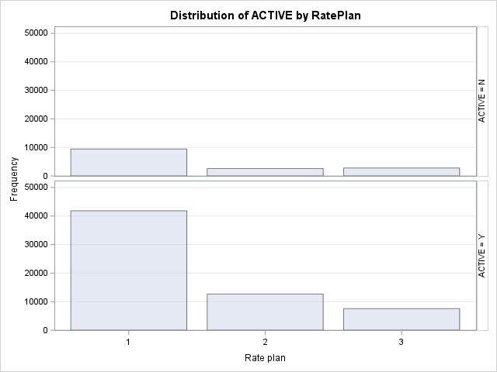The FREQ Procedure

|  |  |  |  |  |  |  |  |  |  |  |  |  |  |  |  |  |  |  |  |  |  |  |  |  |  |  |  |  |  |  |  |  |  |  |  |  |  |  |  |  |  |  |  |  |  |  |  |  |  |  |  |  |  |  |  |  |  |  |  |  |  |  |  |  |  |  |  |  |  |  |  |  |  |  |  |
| --- | --- | --- | --- | --- | --- | --- | --- | --- | --- | --- | --- | --- | --- | --- | --- | --- | --- | --- | --- | --- | --- | --- | --- | --- | --- | --- | --- | --- | --- | --- | --- | --- | --- | --- | --- | --- | --- | --- | --- | --- | --- | --- | --- | --- | --- | --- | --- | --- | --- | --- | --- | --- | --- | --- | --- | --- | --- | --- | --- | --- | --- | --- | --- | --- | --- | --- | --- | --- | --- | --- | --- | --- | --- | --- | --- |
| |  |  |  |  |  | | --- | --- | --- | --- | --- | | |  | | --- | | **Frequency** | | **Percent** | | **Row Pct** | | **Col Pct** | | | |  |  |  |  |  | | --- | --- | --- | --- | --- | | Table of ACTIVE by RatePlan | | | | | | ACTIVE | **RatePlan(Rate plan)** | | | | | **1** | **2** | **3** | **Total** | | N | |  | | --- | | 9437 | | 12.28 | | 63.66 | | 18.40 | | |  | | --- | | 2597 | | 3.38 | | 17.52 | | 17.03 | | |  | | --- | | 2790 | | 3.63 | | 18.82 | | 26.99 | | |  | | --- | | 14824 | | 19.28 | |  | |  | | | Y | |  | | --- | | 41847 | | 54.43 | | 67.44 | | 81.60 | | |  | | --- | | 12657 | | 16.46 | | 20.40 | | 82.97 | | |  | | --- | | 7549 | | 9.82 | | 12.17 | | 73.01 | | |  | | --- | | 62053 | | 80.72 | |  | |  | | | Total | |  | | --- | | 51284 | | 66.71 | | |  | | --- | | 15254 | | 19.84 | | |  | | --- | | 10339 | | 13.45 | | |  | | --- | | 76877 | | 100.00 | | |

|  |
| --- |
| **Statistics for Table of ACTIVE by RatePlan** |

|  |  |  |  |
| --- | --- | --- | --- |
| Statistic | DF | Value | Prob |
| Chi-Square | 2 | 469.6421 | <.0001 |
| Likelihood Ratio Chi-Square | 2 | 438.5681 | <.0001 |
| Mantel-Haenszel Chi-Square | 1 | 251.4548 | <.0001 |
| Phi Coefficient |  | 0.0782 |  |
| Contingency Coefficient |  | 0.0779 |  |
| Cramer's V |  | 0.0782 |  |

|  |
| --- |
| **Sample Size = 76877** |

If condition of chi-square are satisfied and p-value is less than significant level (5%),reject null hypothesis:There is a relationship between them at 5% significant level.

|  |
| --- |
| We can see that the assumptions for chi-square test are met, with p-value of <0.0001, we can reject the null hypothesis and say that there's a relationship between the features. |

|  |
| --- |
| BIVARIATE ANALYSIS OF ACTIVE AND DEALERTYPE FOR SEG |
| Null hypothesis: ACTIVE is independent of the DEALERTYPE |

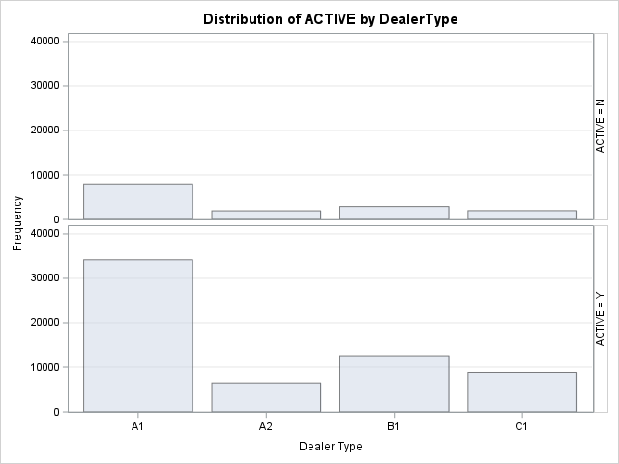The FREQ Procedure

|  |  |  |  |  |  |  |  |  |  |  |  |  |  |  |  |  |  |  |  |  |  |  |  |  |  |  |  |  |  |  |  |  |  |  |  |  |  |  |  |  |  |  |  |  |  |  |  |  |  |  |  |  |  |  |  |  |  |  |  |  |  |  |  |  |  |  |  |  |  |  |  |  |  |  |  |  |  |  |  |  |  |  |  |  |  |  |  |  |  |  |  |
| --- | --- | --- | --- | --- | --- | --- | --- | --- | --- | --- | --- | --- | --- | --- | --- | --- | --- | --- | --- | --- | --- | --- | --- | --- | --- | --- | --- | --- | --- | --- | --- | --- | --- | --- | --- | --- | --- | --- | --- | --- | --- | --- | --- | --- | --- | --- | --- | --- | --- | --- | --- | --- | --- | --- | --- | --- | --- | --- | --- | --- | --- | --- | --- | --- | --- | --- | --- | --- | --- | --- | --- | --- | --- | --- | --- | --- | --- | --- | --- | --- | --- | --- | --- | --- | --- | --- | --- | --- | --- | --- | --- |
| |  |  |  |  |  | | --- | --- | --- | --- | --- | | |  | | --- | | **Frequency** | | **Percent** | | **Row Pct** | | **Col Pct** | | | |  |  |  |  |  |  | | --- | --- | --- | --- | --- | --- | | Table of ACTIVE by DealerType | | | | | | | ACTIVE | **DealerType(Dealer Type)** | | | | | | **A1** | **A2** | **B1** | **C1** | **Total** | | N | |  | | --- | | 7991 | | 10.39 | | 53.91 | | 18.95 | | |  | | --- | | 1946 | | 2.53 | | 13.13 | | 23.08 | | |  | | --- | | 2909 | | 3.78 | | 19.62 | | 18.76 | | |  | | --- | | 1978 | | 2.57 | | 13.34 | | 18.34 | | |  | | --- | | 14824 | | 19.28 | |  | |  | | | Y | |  | | --- | | 34169 | | 44.45 | | 55.06 | | 81.05 | | |  | | --- | | 6484 | | 8.43 | | 10.45 | | 76.92 | | |  | | --- | | 12594 | | 16.38 | | 20.30 | | 81.24 | | |  | | --- | | 8806 | | 11.45 | | 14.19 | | 81.66 | | |  | | --- | | 62053 | | 80.72 | |  | |  | | | Total | |  | | --- | | 42160 | | 54.84 | | |  | | --- | | 8430 | | 10.97 | | |  | | --- | | 15503 | | 20.17 | | |  | | --- | | 10784 | | 14.03 | | |  | | --- | | 76877 | | 100.00 | | |

|  |
| --- |
| **Statistics for Table of ACTIVE by DealerType** |

|  |  |  |  |
| --- | --- | --- | --- |
| Statistic | DF | Value | Prob |
| Chi-Square | 3 | 90.0092 | <.0001 |
| Likelihood Ratio Chi-Square | 3 | 86.5759 | <.0001 |
| Mantel-Haenszel Chi-Square | 1 | 1.3391 | 0.2472 |
| Phi Coefficient |  | 0.0342 |  |
| Contingency Coefficient |  | 0.0342 |  |
| Cramer's V |  | 0.0342 |  |

|  |
| --- |
| **Sample Size = 76877** |

If condition of chi-square are satisfied and p-value is less than significant level (5%),reject null hypothesis:There is a relationship between them at 5% significant level.

We can see that the assumptions for chi-square test are met, with p-value of <0.0001, we can reject the null hypothesis and say that there's a relationship between the features.

|  |
| --- |
| BIVARIATE ANALYSIS OF ACTIVE AND AGE_SEG FOR SEG |
| Null hypothesis: ACTIVE is independent of the AGE_SEG |

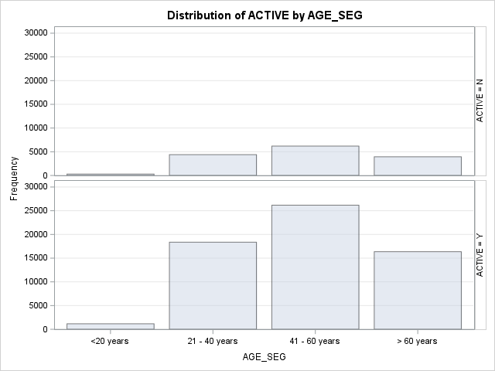The FREQ Procedure

|  |  |  |  |  |  |  |  |  |  |  |  |  |  |  |  |  |  |  |  |  |  |  |  |  |  |  |  |  |  |  |  |  |  |  |  |  |  |  |  |  |  |  |  |  |  |  |  |  |  |  |  |  |  |  |  |  |  |  |  |  |  |  |  |  |  |  |  |  |  |  |  |  |  |  |  |  |  |  |  |  |  |  |  |  |  |  |  |  |  |  |  |
| --- | --- | --- | --- | --- | --- | --- | --- | --- | --- | --- | --- | --- | --- | --- | --- | --- | --- | --- | --- | --- | --- | --- | --- | --- | --- | --- | --- | --- | --- | --- | --- | --- | --- | --- | --- | --- | --- | --- | --- | --- | --- | --- | --- | --- | --- | --- | --- | --- | --- | --- | --- | --- | --- | --- | --- | --- | --- | --- | --- | --- | --- | --- | --- | --- | --- | --- | --- | --- | --- | --- | --- | --- | --- | --- | --- | --- | --- | --- | --- | --- | --- | --- | --- | --- | --- | --- | --- | --- | --- | --- | --- |
| |  |  |  |  |  | | --- | --- | --- | --- | --- | | |  | | --- | | **Frequency** | | **Percent** | | **Row Pct** | | **Col Pct** | | | |  |  |  |  |  |  | | --- | --- | --- | --- | --- | --- | | Table of ACTIVE by AGE_SEG | | | | | | | ACTIVE | **AGE_SEG** | | | | | | **<20 years** | **21 - 40 years** | **41 - 60 years** | **> 60 years** | **Total** | | N | |  | | --- | | 297 | | 0.39 | | 2.00 | | 20.40 | | |  | | --- | | 4392 | | 5.71 | | 29.63 | | 19.30 | | |  | | --- | | 6198 | | 8.06 | | 41.81 | | 19.15 | | |  | | --- | | 3937 | | 5.12 | | 26.56 | | 19.40 | | |  | | --- | | 14824 | | 19.28 | |  | |  | | | Y | |  | | --- | | 1159 | | 1.51 | | 1.87 | | 79.60 | | |  | | --- | | 18365 | | 23.89 | | 29.60 | | 80.70 | | |  | | --- | | 26171 | | 34.04 | | 42.18 | | 80.85 | | |  | | --- | | 16358 | | 21.28 | | 26.36 | | 80.60 | | |  | | --- | | 62053 | | 80.72 | |  | |  | | | Total | |  | | --- | | 1456 | | 1.89 | | |  | | --- | | 22757 | | 29.60 | | |  | | --- | | 32369 | | 42.10 | | |  | | --- | | 20295 | | 26.40 | | |  | | --- | | 76877 | | 100.00 | | |

|  |
| --- |
| **Statistics for Table of ACTIVE by AGE_SEG** |

|  |  |  |  |
| --- | --- | --- | --- |
| Statistic | DF | Value | Prob |
| Chi-Square | 3 | 1.7221 | 0.6320 |
| Likelihood Ratio Chi-Square | 3 | 1.7059 | 0.6356 |
| Mantel-Haenszel Chi-Square | 1 | 0.0005 | 0.9821 |
| Phi Coefficient |  | 0.0047 |  |
| Contingency Coefficient |  | 0.0047 |  |
| Cramer's V |  | 0.0047 |  |

|  |
| --- |
| **Sample Size = 76877** |

If condition of chi-square are satisfied and p-value is less than significant level (5%),reject null hypothesis:There is a relationship between them at 5% significant level.

We can see that the assumptions for chi-square test are met, with p-value of 0.6320, we fail to reject the null hypothesis and can't say that there's a relationship between the features.

|  |
| --- |
| BIVARIATE ANALYSIS OF ACTIVE AND TENURE_SEG FOR SEG |
| Null hypothesis: ACTIVE is independent of the TENURE_SEG |

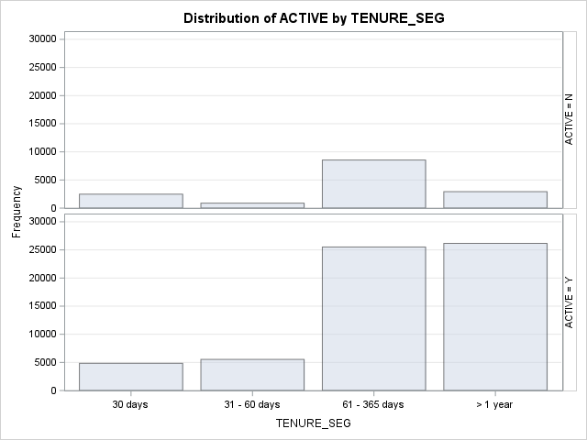The FREQ Procedure

|  |  |  |  |  |  |  |  |  |  |  |  |  |  |  |  |  |  |  |  |  |  |  |  |  |  |  |  |  |  |  |  |  |  |  |  |  |  |  |  |  |  |  |  |  |  |  |  |  |  |  |  |  |  |  |  |  |  |  |  |  |  |  |  |  |  |  |  |  |  |  |  |  |  |  |  |  |  |  |  |  |  |  |  |  |  |  |  |  |  |  |  |
| --- | --- | --- | --- | --- | --- | --- | --- | --- | --- | --- | --- | --- | --- | --- | --- | --- | --- | --- | --- | --- | --- | --- | --- | --- | --- | --- | --- | --- | --- | --- | --- | --- | --- | --- | --- | --- | --- | --- | --- | --- | --- | --- | --- | --- | --- | --- | --- | --- | --- | --- | --- | --- | --- | --- | --- | --- | --- | --- | --- | --- | --- | --- | --- | --- | --- | --- | --- | --- | --- | --- | --- | --- | --- | --- | --- | --- | --- | --- | --- | --- | --- | --- | --- | --- | --- | --- | --- | --- | --- | --- | --- |
| |  |  |  |  |  | | --- | --- | --- | --- | --- | | |  | | --- | | **Frequency** | | **Percent** | | **Row Pct** | | **Col Pct** | | | |  |  |  |  |  |  | | --- | --- | --- | --- | --- | --- | | Table of ACTIVE by TENURE_SEG | | | | | | | ACTIVE | **TENURE_SEG** | | | | | | **30 days** | **31 - 60 days** | **61 - 365 days** | **> 1 year** | **Total** | | N | |  | | --- | | 2476 | | 3.22 | | 16.70 | | 33.85 | | |  | | --- | | 878 | | 1.14 | | 5.92 | | 13.69 | | |  | | --- | | 8546 | | 11.12 | | 57.65 | | 25.09 | | |  | | --- | | 2924 | | 3.80 | | 19.72 | | 10.05 | | |  | | --- | | 14824 | | 19.28 | |  | |  | | | Y | |  | | --- | | 4839 | | 6.29 | | 7.80 | | 66.15 | | |  | | --- | | 5536 | | 7.20 | | 8.92 | | 86.31 | | |  | | --- | | 25517 | | 33.19 | | 41.12 | | 74.91 | | |  | | --- | | 26161 | | 34.03 | | 42.16 | | 89.95 | | |  | | --- | | 62053 | | 80.72 | |  | |  | | | Total | |  | | --- | | 7315 | | 9.52 | | |  | | --- | | 6414 | | 8.34 | | |  | | --- | | 34063 | | 44.31 | | |  | | --- | | 29085 | | 37.83 | | |  | | --- | | 76877 | | 100.00 | | |

|  |
| --- |
| **Statistics for Table of ACTIVE by TENURE_SEG** |

|  |  |  |  |
| --- | --- | --- | --- |
| Statistic | DF | Value | Prob |
| Chi-Square | 3 | 3455.5756 | <.0001 |
| Likelihood Ratio Chi-Square | 3 | 3545.6239 | <.0001 |
| Mantel-Haenszel Chi-Square | 1 | 2636.4859 | <.0001 |
| Phi Coefficient |  | 0.2120 |  |
| Contingency Coefficient |  | 0.2074 |  |
| Cramer's V |  | 0.2120 |  |

|  |
| --- |
| **Sample Size = 76877** |

If condition of chi-square are satisfied and p-value is less than significant level (5%),reject null hypothesis:There is a relationship between them at 5% significant level.

We can see that the assumptions for chi-square test are met, with p-value of <0.0001, we can reject the null hypothesis and say that there's a relationship between the features.

|  |
| --- |
| BIVARIATE ANALYSIS OF ACTIVE AND SALES_SEG FOR SEG |
| Null hypothesis: ACTIVE is independent of the SALES_SEG |

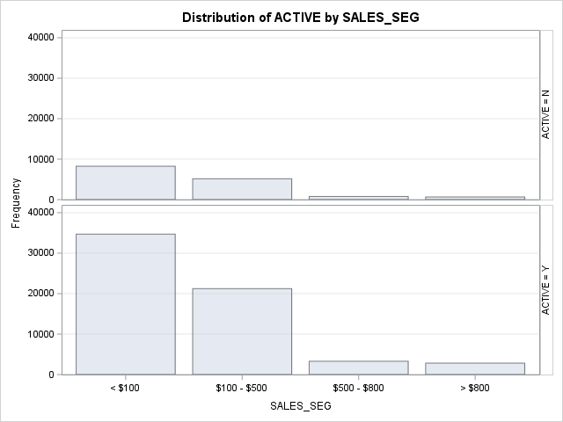The FREQ Procedure

|  |  |  |  |  |  |  |  |  |  |  |  |  |  |  |  |  |  |  |  |  |  |  |  |  |  |  |  |  |  |  |  |  |  |  |  |  |  |  |  |  |  |  |  |  |  |  |  |  |  |  |  |  |  |  |  |  |  |  |  |  |  |  |  |  |  |  |  |  |  |  |  |  |  |  |  |  |  |  |  |  |  |  |  |  |  |  |  |  |  |  |  |
| --- | --- | --- | --- | --- | --- | --- | --- | --- | --- | --- | --- | --- | --- | --- | --- | --- | --- | --- | --- | --- | --- | --- | --- | --- | --- | --- | --- | --- | --- | --- | --- | --- | --- | --- | --- | --- | --- | --- | --- | --- | --- | --- | --- | --- | --- | --- | --- | --- | --- | --- | --- | --- | --- | --- | --- | --- | --- | --- | --- | --- | --- | --- | --- | --- | --- | --- | --- | --- | --- | --- | --- | --- | --- | --- | --- | --- | --- | --- | --- | --- | --- | --- | --- | --- | --- | --- | --- | --- | --- | --- | --- |
| |  |  |  |  |  | | --- | --- | --- | --- | --- | | |  | | --- | | **Frequency** | | **Percent** | | **Row Pct** | | **Col Pct** | | | |  |  |  |  |  |  | | --- | --- | --- | --- | --- | --- | | Table of ACTIVE by SALES_SEG | | | | | | | ACTIVE | **SALES_SEG** | | | | | | **< $100** | **$100 - $500** | **$500 - $800** | **> $800** | **Total** | | N | |  | | --- | | 8249 | | 10.73 | | 55.65 | | 19.20 | | |  | | --- | | 5146 | | 6.69 | | 34.71 | | 19.51 | | |  | | --- | | 775 | | 1.01 | | 5.23 | | 19.09 | | |  | | --- | | 654 | | 0.85 | | 4.41 | | 18.80 | | |  | | --- | | 14824 | | 19.28 | |  | |  | | | Y | |  | | --- | | 34711 | | 45.15 | | 55.94 | | 80.80 | | |  | | --- | | 21233 | | 27.62 | | 34.22 | | 80.49 | | |  | | --- | | 3285 | | 4.27 | | 5.29 | | 80.91 | | |  | | --- | | 2824 | | 3.67 | | 4.55 | | 81.20 | | |  | | --- | | 62053 | | 80.72 | |  | |  | | | Total | |  | | --- | | 42960 | | 55.88 | | |  | | --- | | 26379 | | 34.31 | | |  | | --- | | 4060 | | 5.28 | | |  | | --- | | 3478 | | 4.52 | | |  | | --- | | 76877 | | 100.00 | | |

|  |
| --- |
| **Statistics for Table of ACTIVE by SALES_SEG** |

|  |  |  |  |
| --- | --- | --- | --- |
| Statistic | DF | Value | Prob |
| Chi-Square | 3 | 1.6519 | 0.6477 |
| Likelihood Ratio Chi-Square | 3 | 1.6531 | 0.6474 |
| Mantel-Haenszel Chi-Square | 1 | 0.2960 | 0.5864 |
| Phi Coefficient |  | 0.0046 |  |
| Contingency Coefficient |  | 0.0046 |  |
| Cramer's V |  | 0.0046 |  |

|  |
| --- |
| **Sample Size = 76877** |

If condition of chi-square are satisfied and p-value is less than significant level (5%),reject null hypothesis:There is a relationship between them at 5% significant level.

We can see that the assumptions for chi-square test are met, with p-value of <0.6477, we cannot reject the null hypothesis . Thus, we say that there's not a relationship between the features.

|  |
| --- |
| BIVARIATE ANALYSIS OF ACTIVE AND AGE_SEG FOR SEG |
| Null hypothesis: ACTIVE is independent of the AGE_SEG |

The FREQ Procedure

|  |  |  |  |  |  |  |  |  |  |  |  |  |  |  |  |  |  |  |  |  |  |  |  |  |  |  |  |  |  |  |  |  |  |  |  |  |  |  |  |  |  |  |  |  |  |  |  |  |  |  |  |  |  |  |  |  |  |  |  |  |  |  |  |  |  |  |  |  |  |  |  |  |  |  |  |  |  |  |  |  |  |  |  |  |  |  |  |  |  |  |  |
| --- | --- | --- | --- | --- | --- | --- | --- | --- | --- | --- | --- | --- | --- | --- | --- | --- | --- | --- | --- | --- | --- | --- | --- | --- | --- | --- | --- | --- | --- | --- | --- | --- | --- | --- | --- | --- | --- | --- | --- | --- | --- | --- | --- | --- | --- | --- | --- | --- | --- | --- | --- | --- | --- | --- | --- | --- | --- | --- | --- | --- | --- | --- | --- | --- | --- | --- | --- | --- | --- | --- | --- | --- | --- | --- | --- | --- | --- | --- | --- | --- | --- | --- | --- | --- | --- | --- | --- | --- | --- | --- | --- |
| |  |  |  |  |  | | --- | --- | --- | --- | --- | | |  | | --- | | **Frequency** | | **Percent** | | **Row Pct** | | **Col Pct** | | | |  |  |  |  |  |  | | --- | --- | --- | --- | --- | --- | | Table of ACTIVE by AGE_SEG | | | | | | | ACTIVE | **AGE_SEG** | | | | | | **<20 years** | **21 - 40 years** | **41 - 60 years** | **> 60 years** | **Total** | | N | |  | | --- | | 297 | | 0.39 | | 2.00 | | 20.40 | | |  | | --- | | 4392 | | 5.71 | | 29.63 | | 19.30 | | |  | | --- | | 6198 | | 8.06 | | 41.81 | | 19.15 | | |  | | --- | | 3937 | | 5.12 | | 26.56 | | 19.40 | | |  | | --- | | 14824 | | 19.28 | |  | |  | | | Y | |  | | --- | | 1159 | | 1.51 | | 1.87 | | 79.60 | | |  | | --- | | 18365 | | 23.89 | | 29.60 | | 80.70 | | |  | | --- | | 26171 | | 34.04 | | 42.18 | | 80.85 | | |  | | --- | | 16358 | | 21.28 | | 26.36 | | 80.60 | | |  | | --- | | 62053 | | 80.72 | |  | |  | | | Total | |  | | --- | | 1456 | | 1.89 | | |  | | --- | | 22757 | | 29.60 | | |  | | --- | | 32369 | | 42.10 | | |  | | --- | | 20295 | | 26.40 | | |  | | --- | | 76877 | | 100.00 | | |

|  |
| --- |
| **Statistics for Table of ACTIVE by AGE_SEG** |

|  |  |  |  |
| --- | --- | --- | --- |
| Statistic | DF | Value | Prob |
| Chi-Square | 3 | 1.7221 | 0.6320 |
| Likelihood Ratio Chi-Square | 3 | 1.7059 | 0.6356 |
| Mantel-Haenszel Chi-Square | 1 | 0.0005 | 0.9821 |
| Phi Coefficient |  | 0.0047 |  |
| Contingency Coefficient |  | 0.0047 |  |
| Cramer's V |  | 0.0047 |  |

|  |
| --- |
| **Sample Size = 76877** |

If condition of chi-square are satisfied and p-value is less than significant level (5%),reject null hypothesis:There is a relationship between them at 5% significant level.

We can see that the assumptions for chi-square test are met, with p-value of 0.6320, we fail to reject the null hypothesis and can't say that there's a relationship between the features.

|  |
| --- |
| CATEGORICAL VS CONTINUOUS |

|  |
| --- |
| Null hypothesis: There’s no difference in means |
| 1.Sample distribution must be normal: |
| CLT : |
| If looks normal each group must have more than 30 observations – no need for Shapiro’s test |
| If moderately skewed, each group must have more than 100 observations – no need for Shapiro’s test |
| 2.Groups are independent of one another. |
| 3.There are no major outliers. |
| 4.A check for unequal variances will help determine which version of an independent samples t-test is most appropriate: |
| (Levene’s test, null hypothesis: equal variance) |
| a.If variances are equal, then a pooled t-test is appropriate |
| b.If variances are unequal, then a Satterthwaite (also known as Welch’s) t-test is appropriate |

|  |
| --- |
| RELATION BETWEEN SALES AND ACTIVE |

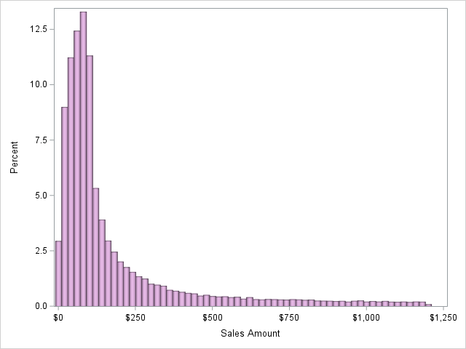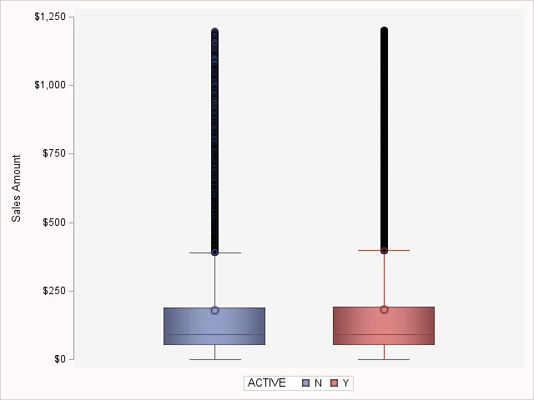The MEANS Procedure

|  |  |  |  |  |  |  |  |  |  |  |  |  |  |
| --- | --- | --- | --- | --- | --- | --- | --- | --- | --- | --- | --- | --- | --- |
| Analysis Variable : Sales Sales Amount | | | | | | | | | | | | | |
| ACTIVE | **N Obs** | **N** | **N Miss** | **Minimum** | **Lower Quartile** | **Median** | **Mean** | **Upper Quartile** | **Maximum** | **Quartile Range** | **Coeff of Variation** | **Lower 95% CL for Mean** | **Upper 95% CL for Mean** |
| N | **14824** | 14824 | 0 | 0.00 | 53.00 | 92.00 | 180.02 | 188.00 | 1197.00 | 135.00 | 128.65 | 176.30 | 183.75 |
| Y | **62053** | 62053 | 0 | 0.00 | 52.00 | 91.00 | 181.63 | 191.00 | 1200.00 | 139.00 | 129.06 | 179.78 | 183.47 |

|  |
| --- |
| We can see a great number of major outliers, so as the data is, it's not possible to use t-test for sales and active features |
| This test will be performed in due time, after trimming major outliers. |

|  |
| --- |
| RELATION BETWEEN AGE AND ACTIVE |

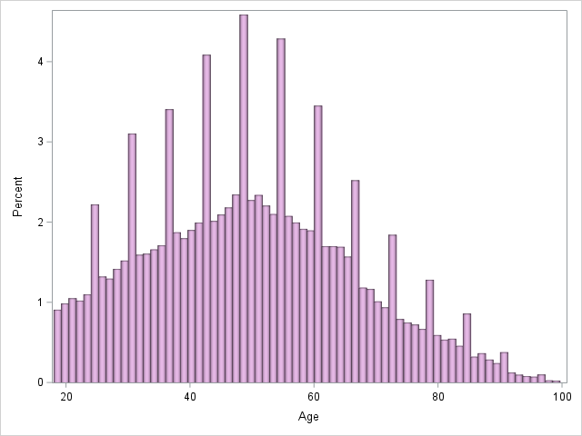The MEANS Procedure

|  |  |  |  |  |  |  |  |  |  |  |  |  |  |
| --- | --- | --- | --- | --- | --- | --- | --- | --- | --- | --- | --- | --- | --- |
| Analysis Variable : Age Age | | | | | | | | | | | | | |
| ACTIVE | **N Obs** | **N** | **N Miss** | **Minimum** | **Lower Quartile** | **Median** | **Mean** | **Upper Quartile** | **Maximum** | **Quartile Range** | **Coeff of Variation** | **Lower 95% CL for Mean** | **Upper 95% CL for Mean** |
| N | **14824** | 14824 | 0 | 19.00 | 37.00 | 49.00 | 49.77 | 61.00 | 98.00 | 24.00 | 33.92 | 49.50 | 50.04 |
| Y | **62053** | 62053 | 0 | 19.00 | 37.00 | 49.00 | 49.78 | 61.00 | 99.00 | 24.00 | 33.67 | 49.65 | 49.91 |

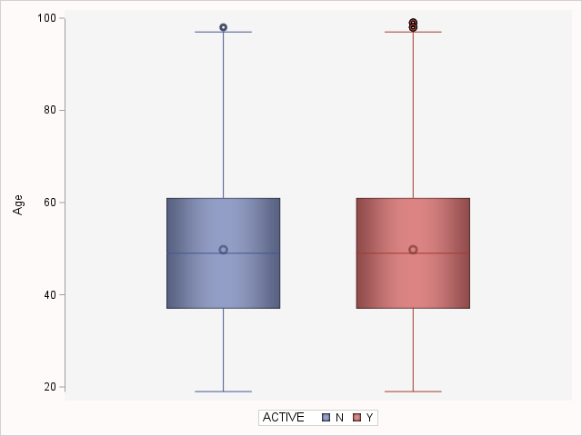

|  |
| --- |
| We can see that in each group between active and age features we have more than 100 observations, so there is no need to test |
| for normal distribution. Let us test for homogeneity of variances: |

The GLM Procedure

|  |  |  |
| --- | --- | --- |
| Class Level Information | | |
| Class | **Levels** | **Values** |
| ACTIVE | 2 | N Y |

|  |  |
| --- | --- |
| Number of Observations Read | 76877 |
| Number of Observations Used | 76877 |

The GLM Procedure

Dependent Variable: Age Age

|  |  |  |  |  |  |
| --- | --- | --- | --- | --- | --- |
| Source | DF | Sum of Squares | Mean Square | F Value | Pr > F |
| Model | 1 | 1.02 | 1.02 | 0.00 | 0.9520 |
| Error | 76875 | 21657940.05 | 281.73 |  |  |
| Corrected Total | 76876 | 21657941.07 |  |  |  |

|  |  |  |  |
| --- | --- | --- | --- |
| R-Square | Coeff Var | Root MSE | Age Mean |
| 0.000000 | 33.71869 | 16.78479 | 49.77891 |

|  |  |  |  |  |  |
| --- | --- | --- | --- | --- | --- |
| Source | DF | Type I SS | Mean Square | F Value | Pr > F |
| ACTIVE | 1 | 1.02065420 | 1.02065420 | 0.00 | 0.9520 |

|  |  |  |  |  |  |
| --- | --- | --- | --- | --- | --- |
| Source | DF | Type III SS | Mean Square | F Value | Pr > F |
| ACTIVE | 1 | 1.02065420 | 1.02065420 | 0.00 | 0.9520 |

The GLM Procedure

|  |  |  |  |  |  |
| --- | --- | --- | --- | --- | --- |
| Levene's Test for Homogeneity of Age Variance ANOVA of Absolute Deviations from Group Means | | | | | |
| Source | **DF** | **Sum of Squares** | **Mean Square** | **F Value** | **Pr > F** |
| ACTIVE | 1 | 148.5 | 148.5 | 1.59 | 0.2072 |
| Error | 76875 | 7174743 | 93.3300 |  |  |

|  |  |  |  |
| --- | --- | --- | --- |
| Welch's ANOVA for Age | | | |
| Source | **DF** | **F Value** | **Pr > F** |
| ACTIVE | 1.0000 | 0.00 | 0.9522 |
| Error | 22327.9 |  |  |

The GLM Procedure

|  |  |  |  |
| --- | --- | --- | --- |
| Level of ACTIVE | N | Age | |
| **Mean** | **Std Dev** |
| N | **14824** | 49.7714517 | 16.8843539 |
| Y | **62053** | 49.7806875 | 16.7609233 |

We can see that Levene's test points to equal variances (pvalue of 0.2072), since we fail to reject null hypothesis at 5% significance

The TTEST Procedure

Variable: Age (Age)

|  |  |  |  |  |  |  |  |
| --- | --- | --- | --- | --- | --- | --- | --- |
| ACTIVE | Method | N | Mean | Std Dev | Std Err | Minimum | Maximum |
| N |  | 14824 | 49.7715 | 16.8844 | 0.1387 | 19.0000 | 98.0000 |
| Y |  | 62053 | 49.7807 | 16.7609 | 0.0673 | 19.0000 | 99.0000 |
| Diff (1-2) | **Pooled** |  | -0.00924 | 16.7848 | 0.1534 |  |  |
| Diff (1-2) | **Satterthwaite** |  | -0.00924 |  | 0.1541 |  |  |

|  |  |  |  |  |  |  |  |
| --- | --- | --- | --- | --- | --- | --- | --- |
| ACTIVE | Method | Mean | 95% CL Mean | | Std Dev | 95% CL Std Dev | |
| N |  | 49.7715 | 49.4996 | 50.0433 | 16.8844 | 16.6943 | 17.0788 |
| Y |  | 49.7807 | 49.6488 | 49.9126 | 16.7609 | 16.6682 | 16.8547 |
| Diff (1-2) | **Pooled** | -0.00924 | -0.3100 | 0.2915 | 16.7848 | 16.7013 | 16.8691 |
| Diff (1-2) | **Satterthwaite** | -0.00924 | -0.3114 | 0.2929 |  |  |  |

|  |  |  |  |  |
| --- | --- | --- | --- | --- |
| Method | Variances | DF | t Value | Pr > |t| |
| Pooled | Equal | 76875 | -0.06 | 0.9520 |
| Satterthwaite | Unequal | 22328 | -0.06 | 0.9522 |

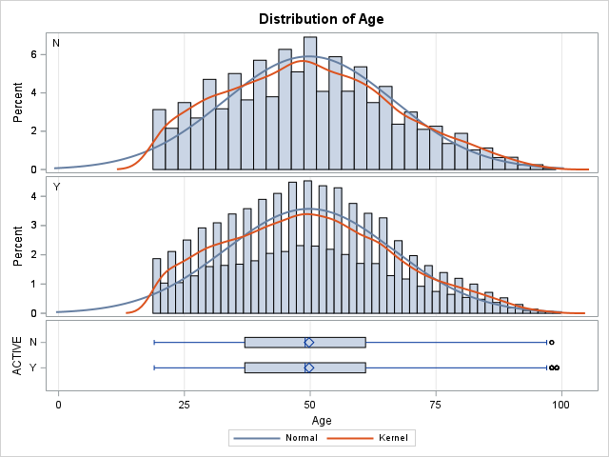

|  |  |  |  |  |
| --- | --- | --- | --- | --- |
| Equality of Variances | | | | |
| Method | **Num DF** | **Den DF** | **F Value** | **Pr > F** |
| Folded F | 14823 | 62052 | 1.01 | 0.2546 |

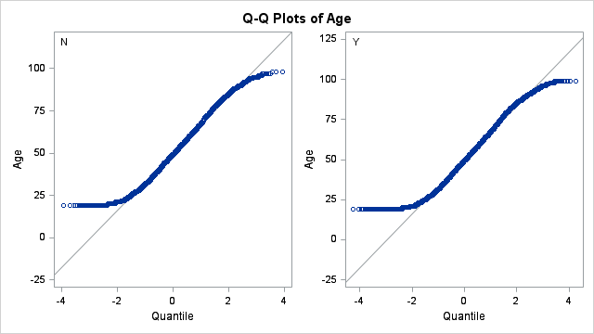

We can see that with a pvalue of 0.9520, we failed to reject null hypothesis. Thus, the two groups are equal.

|  |
| --- |
| Testing association - TENURE SEGMENT AND GOODCREDIT, RATEPLAN, AND DEALERTYPE |

|  |
| --- |
| Assumptions: |
| 2. The sample observations should be independent. No individual item should be included twice or more in the sample" |
| 3. No expected frequencies should be small. Preferably each expected frequency should be larger than 10 but in any case not less than 5. |
|  |
| If condition of chi-square are satisfied and p-value is less than significant level (5%), reject null hypothesis: |
| - There is a relationship between them at 5% significant level. |

|  |
| --- |
| BIVARIATE ANALYSIS OF TENURE_SEG AND GOODCREDIT FOR SEG |
| Null hypothesis: TENURE_SEG is independent of the GOODCREDIT |

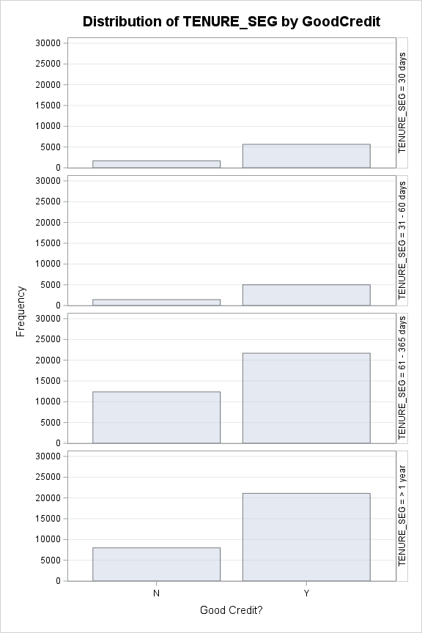The FREQ Procedure

|  |  |  |  |  |  |  |  |  |  |  |  |  |  |  |  |  |  |  |  |  |  |  |  |  |  |  |  |  |  |  |  |  |  |  |  |  |  |  |  |  |  |  |  |  |  |  |  |  |  |  |  |  |  |  |  |  |  |  |  |  |  |  |  |  |  |  |  |  |  |  |  |  |  |  |  |  |  |  |  |  |  |  |  |  |  |  |  |  |  |  |  |
| --- | --- | --- | --- | --- | --- | --- | --- | --- | --- | --- | --- | --- | --- | --- | --- | --- | --- | --- | --- | --- | --- | --- | --- | --- | --- | --- | --- | --- | --- | --- | --- | --- | --- | --- | --- | --- | --- | --- | --- | --- | --- | --- | --- | --- | --- | --- | --- | --- | --- | --- | --- | --- | --- | --- | --- | --- | --- | --- | --- | --- | --- | --- | --- | --- | --- | --- | --- | --- | --- | --- | --- | --- | --- | --- | --- | --- | --- | --- | --- | --- | --- | --- | --- | --- | --- | --- | --- | --- | --- | --- | --- |
| |  |  |  |  |  | | --- | --- | --- | --- | --- | | |  | | --- | | **Frequency** | | **Percent** | | **Row Pct** | | **Col Pct** | | | |  |  |  |  | | --- | --- | --- | --- | | Table of TENURE_SEG by GoodCredit | | | | | TENURE_SEG | **GoodCredit(Good Credit?)** | | | | **N** | **Y** | **Total** | | 30 days | |  | | --- | | 1663 | | 2.16 | | 22.73 | | 7.09 | | |  | | --- | | 5652 | | 7.35 | | 77.27 | | 10.58 | | |  | | --- | | 7315 | | 9.52 | |  | |  | | | 31 - 60 days | |  | | --- | | 1423 | | 1.85 | | 22.19 | | 6.07 | | |  | | --- | | 4991 | | 6.49 | | 77.81 | | 9.34 | | |  | | --- | | 6414 | | 8.34 | |  | |  | | | 61 - 365 days | |  | | --- | | 12375 | | 16.10 | | 36.33 | | 52.79 | | |  | | --- | | 21688 | | 28.21 | | 63.67 | | 40.59 | | |  | | --- | | 34063 | | 44.31 | |  | |  | | | > 1 year | |  | | --- | | 7980 | | 10.38 | | 27.44 | | 34.04 | | |  | | --- | | 21105 | | 27.45 | | 72.56 | | 39.50 | | |  | | --- | | 29085 | | 37.83 | |  | |  | | | Total | |  | | --- | | 23441 | | 30.49 | | |  | | --- | | 53436 | | 69.51 | | |  | | --- | | 76877 | | 100.00 | | |

|  |
| --- |
| **Statistics for Table of TENURE_SEG by GoodCredit** |

|  |  |  |  |
| --- | --- | --- | --- |
| Statistic | DF | Value | Prob |
| Chi-Square | 3 | 1092.3229 | <.0001 |
| Likelihood Ratio Chi-Square | 3 | 1102.3559 | <.0001 |
| Mantel-Haenszel Chi-Square | 1 | 123.4011 | <.0001 |
| Phi Coefficient |  | 0.1192 |  |
| Contingency Coefficient |  | 0.1184 |  |
| Cramer's V |  | 0.1192 |  |

|  |
| --- |
| **Sample Size = 76877** |

If condition of chi-square are satisfied and p-value is less than significant level (5%),reject null hypothesis:There is a relationship between them at 5% significant level.

|  |
| --- |
| The assumptions are met. And, as pvalue is <.0001, we can reject the null hypothesis at 5% significance level and say that there's |
| an association between the features. |

|  |
| --- |
| BIVARIATE ANALYSIS OF TENURE_SEG AND RATEPLAN FOR SEG |
| Null hypothesis: TENURE_SEG is independent of the RATEPLAN |

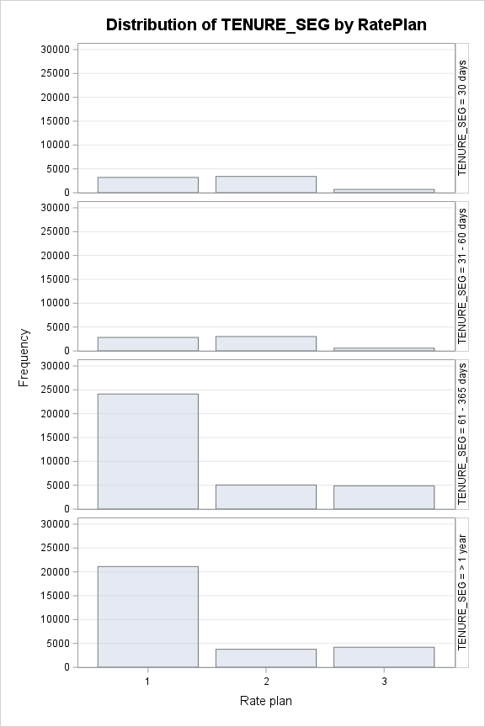

The FREQ Procedure

|  |  |  |  |  |  |  |  |  |  |  |  |  |  |  |  |  |  |  |  |  |  |  |  |  |  |  |  |  |  |  |  |  |  |  |  |  |  |  |  |  |  |  |  |  |  |  |  |  |  |  |  |  |  |  |  |  |  |  |  |  |  |  |  |  |  |  |  |  |  |  |  |  |  |  |  |  |  |  |  |  |  |  |  |  |  |  |  |  |  |  |  |  |  |  |  |  |  |  |  |  |  |  |  |  |  |  |  |  |  |  |  |  |  |  |  |  |  |
| --- | --- | --- | --- | --- | --- | --- | --- | --- | --- | --- | --- | --- | --- | --- | --- | --- | --- | --- | --- | --- | --- | --- | --- | --- | --- | --- | --- | --- | --- | --- | --- | --- | --- | --- | --- | --- | --- | --- | --- | --- | --- | --- | --- | --- | --- | --- | --- | --- | --- | --- | --- | --- | --- | --- | --- | --- | --- | --- | --- | --- | --- | --- | --- | --- | --- | --- | --- | --- | --- | --- | --- | --- | --- | --- | --- | --- | --- | --- | --- | --- | --- | --- | --- | --- | --- | --- | --- | --- | --- | --- | --- | --- | --- | --- | --- | --- | --- | --- | --- | --- | --- | --- | --- | --- | --- | --- | --- | --- | --- | --- | --- | --- | --- | --- | --- | --- | --- |
| |  |  |  |  |  | | --- | --- | --- | --- | --- | | |  | | --- | | **Frequency** | | **Percent** | | **Row Pct** | | **Col Pct** | | | |  |  |  |  |  | | --- | --- | --- | --- | --- | | Table of TENURE_SEG by RatePlan | | | | | | TENURE_SEG | **RatePlan(Rate plan)** | | | | | **1** | **2** | **3** | **Total** | | 30 days | |  | | --- | | 3209 | | 4.17 | | 43.87 | | 6.26 | | |  | | --- | | 3411 | | 4.44 | | 46.63 | | 22.36 | | |  | | --- | | 695 | | 0.90 | | 9.50 | | 6.72 | | |  | | --- | | 7315 | | 9.52 | |  | |  | | | 31 - 60 days | |  | | --- | | 2829 | | 3.68 | | 44.11 | | 5.52 | | |  | | --- | | 3016 | | 3.92 | | 47.02 | | 19.77 | | |  | | --- | | 569 | | 0.74 | | 8.87 | | 5.50 | | |  | | --- | | 6414 | | 8.34 | |  | |  | | | 61 - 365 days | |  | | --- | | 24128 | | 31.39 | | 70.83 | | 47.05 | | |  | | --- | | 5058 | | 6.58 | | 14.85 | | 33.16 | | |  | | --- | | 4877 | | 6.34 | | 14.32 | | 47.17 | | |  | | --- | | 34063 | | 44.31 | |  | |  | | | > 1 year | |  | | --- | | 21118 | | 27.47 | | 72.61 | | 41.18 | | |  | | --- | | 3769 | | 4.90 | | 12.96 | | 24.71 | | |  | | --- | | 4198 | | 5.46 | | 14.43 | | 40.60 | | |  | | --- | | 29085 | | 37.83 | |  | |  | | | Total | |  | | --- | | 51284 | | 66.71 | | |  | | --- | | 15254 | | 19.84 | | |  | | --- | | 10339 | | 13.45 | | |  | | --- | | 76877 | | 100.00 | | |

|  |
| --- |
| **Statistics for Table of TENURE_SEG by RatePlan** |

|  |  |  |  |
| --- | --- | --- | --- |
| Statistic | DF | Value | Prob |
| Chi-Square | 6 | 7682.7184 | <.0001 |
| Likelihood Ratio Chi-Square | 6 | 6579.6396 | <.0001 |
| Mantel-Haenszel Chi-Square | 1 | 320.1327 | <.0001 |
| Phi Coefficient |  | 0.3161 |  |
| Contingency Coefficient |  | 0.3014 |  |
| Cramer's V |  | 0.2235 |  |

|  |
| --- |
| **Sample Size = 76877** |

If condition of chi-square are satisfied and p-value is less than significant level (5%),reject null hypothesis:There is a relationship between them at 5% significant level.

The assumptions are met. And, as pvalue is <.0001, we can reject the null hypothesis at 5% significance level and say that there's an association between the features

|  |
| --- |
|  |

|  |
| --- |
| BIVARIATE ANALYSIS OF TENURE_SEG AND DEALERTYPE FOR SEG |
| Null hypothesis: TENURE_SEG is independent of the DEALERTYPE |

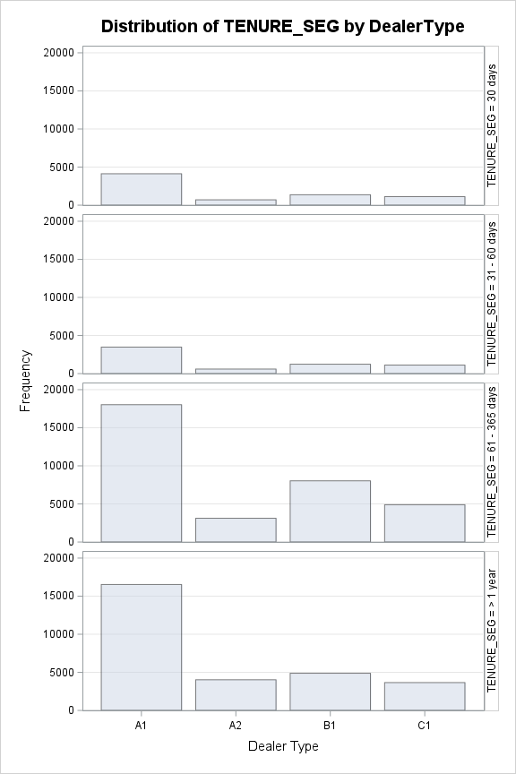The FREQ Procedure

|  |  |  |  |  |  |  |  |  |  |  |  |  |  |  |  |  |  |  |  |  |  |  |  |  |  |  |  |  |  |  |  |  |  |  |  |  |  |  |  |  |  |  |  |  |  |  |  |  |  |  |  |  |  |  |  |  |  |  |  |  |  |  |  |  |  |  |  |  |  |  |  |  |  |  |  |  |  |  |  |  |  |  |  |  |  |  |  |  |  |  |  |  |  |  |  |  |  |  |  |  |  |  |  |  |  |  |  |  |  |  |  |  |  |  |  |  |  |  |  |  |  |  |  |  |  |  |  |  |  |  |  |  |  |  |  |  |  |  |  |  |  |  |  |
| --- | --- | --- | --- | --- | --- | --- | --- | --- | --- | --- | --- | --- | --- | --- | --- | --- | --- | --- | --- | --- | --- | --- | --- | --- | --- | --- | --- | --- | --- | --- | --- | --- | --- | --- | --- | --- | --- | --- | --- | --- | --- | --- | --- | --- | --- | --- | --- | --- | --- | --- | --- | --- | --- | --- | --- | --- | --- | --- | --- | --- | --- | --- | --- | --- | --- | --- | --- | --- | --- | --- | --- | --- | --- | --- | --- | --- | --- | --- | --- | --- | --- | --- | --- | --- | --- | --- | --- | --- | --- | --- | --- | --- | --- | --- | --- | --- | --- | --- | --- | --- | --- | --- | --- | --- | --- | --- | --- | --- | --- | --- | --- | --- | --- | --- | --- | --- | --- | --- | --- | --- | --- | --- | --- | --- | --- | --- | --- | --- | --- | --- | --- | --- | --- | --- | --- | --- | --- | --- | --- | --- | --- | --- | --- |
| |  |  |  |  |  | | --- | --- | --- | --- | --- | | |  | | --- | | **Frequency** | | **Percent** | | **Row Pct** | | **Col Pct** | | | |  |  |  |  |  |  | | --- | --- | --- | --- | --- | --- | | Table of TENURE_SEG by DealerType | | | | | | | TENURE_SEG | **DealerType(Dealer Type)** | | | | | | **A1** | **A2** | **B1** | **C1** | **Total** | | 30 days | |  | | --- | | 4125 | | 5.37 | | 56.39 | | 9.78 | | |  | | --- | | 701 | | 0.91 | | 9.58 | | 8.32 | | |  | | --- | | 1367 | | 1.78 | | 18.69 | | 8.82 | | |  | | --- | | 1122 | | 1.46 | | 15.34 | | 10.40 | | |  | | --- | | 7315 | | 9.52 | |  | |  | | | 31 - 60 days | |  | | --- | | 3477 | | 4.52 | | 54.21 | | 8.25 | | |  | | --- | | 594 | | 0.77 | | 9.26 | | 7.05 | | |  | | --- | | 1229 | | 1.60 | | 19.16 | | 7.93 | | |  | | --- | | 1114 | | 1.45 | | 17.37 | | 10.33 | | |  | | --- | | 6414 | | 8.34 | |  | |  | | | 61 - 365 days | |  | | --- | | 18024 | | 23.45 | | 52.91 | | 42.75 | | |  | | --- | | 3114 | | 4.05 | | 9.14 | | 36.94 | | |  | | --- | | 8031 | | 10.45 | | 23.58 | | 51.80 | | |  | | --- | | 4894 | | 6.37 | | 14.37 | | 45.38 | | |  | | --- | | 34063 | | 44.31 | |  | |  | | | > 1 year | |  | | --- | | 16534 | | 21.51 | | 56.85 | | 39.22 | | |  | | --- | | 4021 | | 5.23 | | 13.82 | | 47.70 | | |  | | --- | | 4876 | | 6.34 | | 16.76 | | 31.45 | | |  | | --- | | 3654 | | 4.75 | | 12.56 | | 33.88 | | |  | | --- | | 29085 | | 37.83 | |  | |  | | | Total | |  | | --- | | 42160 | | 54.84 | | |  | | --- | | 8430 | | 10.97 | | |  | | --- | | 15503 | | 20.17 | | |  | | --- | | 10784 | | 14.03 | | |  | | --- | | 76877 | | 100.00 | | |

If condition of chi-square are satisfied and p-value is less than significant level (5%),reject null hypothesis: There is a relationship between them at 5% significant level.

The assumptions are met. And, as pvalue is <.0001, we can reject the null hypothesis at 5% significance level and say that there is an association between the features.

|  |
| --- |
| **Statistics for Table of TENURE_SEG by DealerType** |

|  |  |  |  |
| --- | --- | --- | --- |
| Statistic | DF | Value | Prob |
| Chi-Square | 9 | 879.7876 | <.0001 |
| Likelihood Ratio Chi-Square | 9 | 868.8502 | <.0001 |
| Mantel-Haenszel Chi-Square | 1 | 231.6874 | <.0001 |
| Phi Coefficient |  | 0.1070 |  |
| Contingency Coefficient |  | 0.1064 |  |
| Cramer's V |  | 0.0618 |  |

|  |
| --- |
| **Sample Size = 76877** |

|  |
| --- |
| CATEGORICAL VS CONTINUOUS |
| Testing association - SALES AMOUNT AND ACCOUNT STATUS, GOOD CREDIT AND AGE SEGMENTS |

|  |
| --- |
| Null hypothesis: There’s no difference in means |
| 1.Sample distribution must be normal: |
| CLT : |
| If looks normal each group must have more than 30 observations – no need for Shapiro’s test |
| If moderately skewed, each group must have more than 100 observations – no need for Shapiro’s test |
| 2.Groups are independent of one another. |
| 3.There are no major outliers. |
| 4.A check for unequal variances will help determine which version of an independent samples t-test is most appropriate: |
| (Levene’s test, null hypothesis: equal variance) |
| a.If variances are equal, then a pooled t-test is appropriate |
| b.If variances are unequal, then a Satterthwaite (also known as Welch’s) t-test is appropriate |

|  |
| --- |
| RELATION BETWEEN SALES AND ACTIVE |

The MEANS Procedure

|  |  |  |  |  |  |  |  |  |  |  |  |  |  |
| --- | --- | --- | --- | --- | --- | --- | --- | --- | --- | --- | --- | --- | --- |
| Analysis Variable : Sales Sales Amount | | | | | | | | | | | | | |
| ACTIVE | **N Obs** | **N** | **N Miss** | **Minimum** | **Lower Quartile** | **Median** | **Mean** | **Upper Quartile** | **Maximum** | **Quartile Range** | **Coeff of Variation** | **Lower 95% CL for Mean** | **Upper 95% CL for Mean** |
| N | **14824** | 14824 | 0 | 0.00 | 53.00 | 92.00 | 180.02 | 188.00 | 1197.00 | 135.00 | 128.65 | 176.30 | 183.75 |
| Y | **62053** | 62053 | 0 | 0.00 | 52.00 | 91.00 | 181.63 | 191.00 | 1200.00 | 139.00 | 129.06 | 179.78 | 183.47 |



|  |
| --- |
| Sales greater than $390 (~Q3+3*IQR) will be dropped to perform the test. |

|  |
| --- |
| RELATION BETWEEN SALES AND ACTIVE |

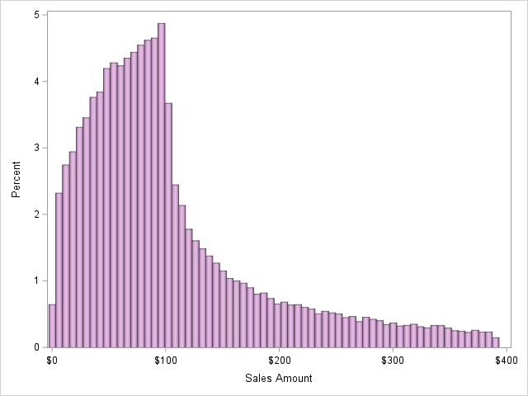The MEANS Procedure

|  |  |  |  |  |  |  |  |  |  |  |  |  |  |
| --- | --- | --- | --- | --- | --- | --- | --- | --- | --- | --- | --- | --- | --- |
| Analysis Variable : Sales Sales Amount | | | | | | | | | | | | | |
| ACTIVE | **N Obs** | **N** | **N Miss** | **Minimum** | **Lower Quartile** | **Median** | **Mean** | **Upper Quartile** | **Maximum** | **Quartile Range** | **Coeff of Variation** | **Lower 95% CL for Mean** | **Upper 95% CL for Mean** |
| N | **12973** | 12973 | 0 | 0.00 | 48.00 | 82.00 | 103.33 | 130.00 | 390.00 | 82.00 | 78.79 | 101.93 | 104.74 |
| Y | **54056** | 54056 | 0 | 0.00 | 47.00 | 82.00 | 102.75 | 129.00 | 390.00 | 82.00 | 79.59 | 102.07 | 103.44 |

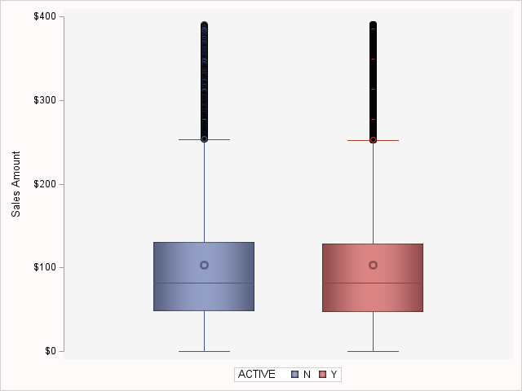

We can see that in each group between active and age features we have more than 100 observations, so there's no need to test for normality.

Let's test for homogeneity of variances:

The GLM Procedure

|  |  |  |
| --- | --- | --- |
| Class Level Information | | |
| Class | **Levels** | **Values** |
| ACTIVE | 2 | N Y |

|  |  |
| --- | --- |
| Number of Observations Read | 67029 |
| Number of Observations Used | 67029 |

The GLM Procedure

Dependent Variable: Sales Sales Amount

|  |  |  |  |  |  |
| --- | --- | --- | --- | --- | --- |
| Source | DF | Sum of Squares | Mean Square | F Value | Pr > F |
| Model | 1 | 3519.3 | 3519.3 | 0.53 | 0.4678 |
| Error | 67027 | 447480229.2 | 6676.1 |  |  |
| Corrected Total | 67028 | 447483748.5 |  |  |  |

|  |  |  |  |
| --- | --- | --- | --- |
| R-Square | Coeff Var | Root MSE | Sales Mean |
| 0.000008 | 79.43046 | 81.70752 | 102.8667 |

|  |  |  |  |  |  |
| --- | --- | --- | --- | --- | --- |
| Source | DF | Type I SS | Mean Square | F Value | Pr > F |
| ACTIVE | 1 | 3519.315269 | 3519.315269 | 0.53 | 0.4678 |

|  |  |  |  |  |  |
| --- | --- | --- | --- | --- | --- |
| Source | DF | Type III SS | Mean Square | F Value | Pr > F |
| ACTIVE | 1 | 3519.315269 | 3519.315269 | 0.53 | 0.4678 |

The GLM Procedure

|  |  |  |  |  |  |
| --- | --- | --- | --- | --- | --- |
| Levene's Test for Homogeneity of Sales Variance ANOVA of Absolute Deviations from Group Means | | | | | |
| Source | **DF** | **Sum of Squares** | **Mean Square** | **F Value** | **Pr > F** |
| ACTIVE | 1 | 117.5 | 117.5 | 0.04 | 0.8427 |
| Error | 67027 | 1.9985E8 | 2981.6 |  |  |

|  |  |  |  |
| --- | --- | --- | --- |
| Welch's ANOVA for Sales | | | |
| Source | **DF** | **F Value** | **Pr > F** |
| ACTIVE | 1.0000 | 0.53 | 0.4666 |
| Error | 19736.7 |  |  |

The GLM Procedure

|  |  |  |  |
| --- | --- | --- | --- |
| Level of ACTIVE | N | Sales | |
| **Mean** | **Std Dev** |
| N | **12973** | 103.334464 | 81.4151231 |
| Y | **54056** | 102.754477 | 81.7775346 |

|  |
| --- |
| We can see that Levene's test points to equal variances (pvalue of 0.8427), since we fail to reject null hypothesis at 5% significance level. |

The TTEST Procedure

Variable: Sales (Sales Amount)

|  |  |  |  |  |  |  |  |
| --- | --- | --- | --- | --- | --- | --- | --- |
| ACTIVE | Method | N | Mean | Std Dev | Std Err | Minimum | Maximum |
| N |  | 12973 | 103.3 | 81.4151 | 0.7148 | 0 | 390.0 |
| Y |  | 54056 | 102.8 | 81.7775 | 0.3517 | 0 | 390.0 |
| Diff (1-2) | **Pooled** |  | 0.5800 | 81.7075 | 0.7988 |  |  |
| Diff (1-2) | **Satterthwaite** |  | 0.5800 |  | 0.7967 |  |  |

|  |  |  |  |  |  |  |  |
| --- | --- | --- | --- | --- | --- | --- | --- |
| ACTIVE | Method | Mean | 95% CL Mean | | Std Dev | 95% CL Std Dev | |
| N |  | 103.3 | 101.9 | 104.7 | 81.4151 | 80.4364 | 82.4181 |
| Y |  | 102.8 | 102.1 | 103.4 | 81.7775 | 81.2930 | 82.2679 |
| Diff (1-2) | **Pooled** | 0.5800 | -0.9857 | 2.1457 | 81.7075 | 81.2725 | 82.1473 |
| Diff (1-2) | **Satterthwaite** | 0.5800 | -0.9815 | 2.1415 |  |  |  |

|  |  |  |  |  |
| --- | --- | --- | --- | --- |
| Method | Variances | DF | t Value | Pr > |t| |
| Pooled | Equal | 67027 | 0.73 | 0.4678 |
| Satterthwaite | Unequal | 19737 | 0.73 | 0.4666 |

|  |  |  |  |  |
| --- | --- | --- | --- | --- |
| Equality of Variances | | | | |
| Method | **Num DF** | **Den DF** | **F Value** | **Pr > F** |
| Folded F | 54055 | 12972 | 1.01 | 0.5228 |

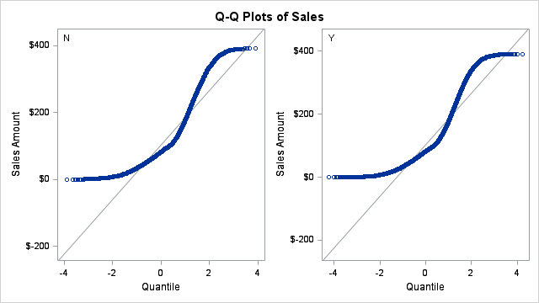

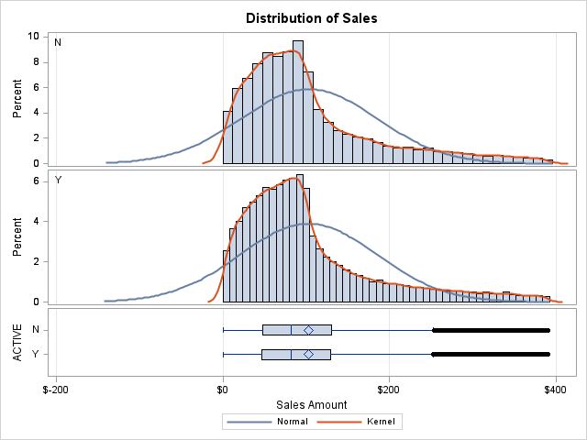

We can see that with a pvalue of 0.4678, we failed to reject null hypothesis. Thus, the two groups are equal

|  |
| --- |
| RELATION BETWEEN SALES AND GOODCREDIT |

The MEANS Procedure

|  |  |  |  |  |  |  |  |  |  |  |  |  |  |
| --- | --- | --- | --- | --- | --- | --- | --- | --- | --- | --- | --- | --- | --- |
| Analysis Variable : Sales Sales Amount | | | | | | | | | | | | | |
| Good Credit? | **N Obs** | **N** | **N Miss** | **Minimum** | **Lower Quartile** | **Median** | **Mean** | **Upper Quartile** | **Maximum** | **Quartile Range** | **Coeff of Variation** | **Lower 95% CL for Mean** | **Upper 95% CL for Mean** |
| N | **23441** | 23441 | 0 | 0.00 | 52.00 | 91.00 | 181.71 | 190.00 | 1200.00 | 138.00 | 129.41 | 178.70 | 184.72 |
| Y | **53436** | 53436 | 0 | 0.00 | 53.00 | 91.00 | 181.15 | 191.00 | 1200.00 | 138.00 | 128.79 | 179.17 | 183.13 |

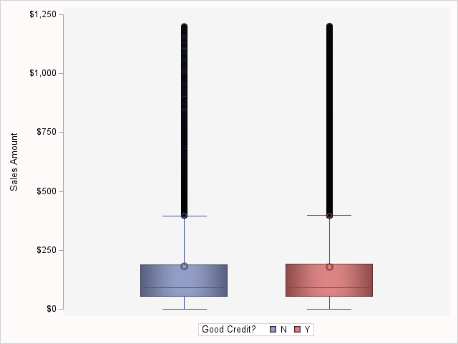

|  |
| --- |
| We can see a great number of major outliers, so as the data is, it's not possible to use t-test for sales and active features. |
| Sales greater than $600 (~Q3+3*IQR) will be dropped to perform the test. |

|  |
| --- |
| RELATION BETWEEN SALES AND GOODCREDIT |

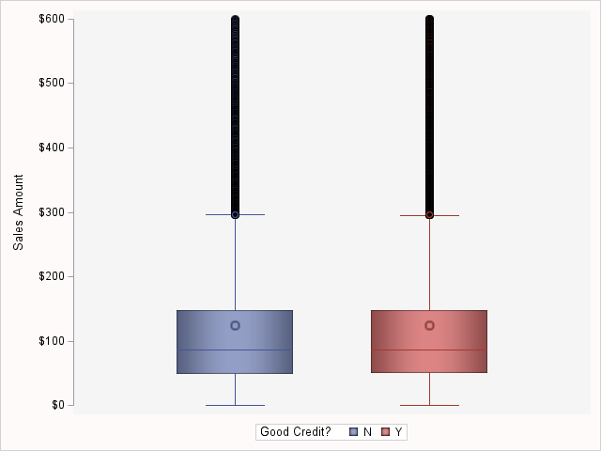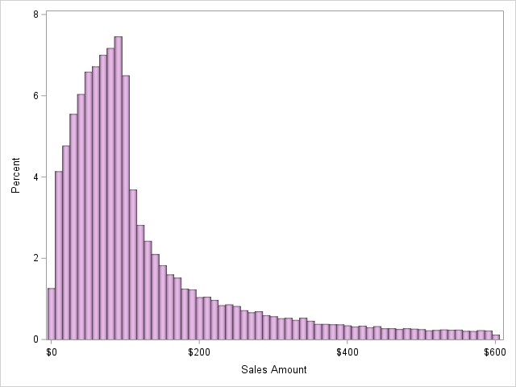The MEANS Procedure

|  |  |  |  |  |  |  |  |  |  |  |  |  |  |
| --- | --- | --- | --- | --- | --- | --- | --- | --- | --- | --- | --- | --- | --- |
| Analysis Variable : Sales Sales Amount | | | | | | | | | | | | | |
| Good Credit? | **N Obs** | **N** | **N Miss** | **Minimum** | **Lower Quartile** | **Median** | **Mean** | **Upper Quartile** | **Maximum** | **Quartile Range** | **Coeff of Variation** | **Lower 95% CL for Mean** | **Upper 95% CL for Mean** |
| N | **21625** | 21625 | 0 | 0.00 | 49.00 | 86.00 | 123.82 | 148.00 | 600.00 | 99.00 | 95.86 | 122.24 | 125.40 |
| Y | **49347** | 49347 | 0 | 0.00 | 50.00 | 86.00 | 124.30 | 148.00 | 600.00 | 98.00 | 96.10 | 123.25 | 125.35 |

.

We can see that in each group between active and age features we have more than 100 observations, so there's no need to test for normality

Let's test for homogeneity of variances:

The GLM Procedure

|  |  |  |
| --- | --- | --- |
| Class Level Information | | |
| Class | **Levels** | **Values** |
| GoodCredit | 2 | N Y |

|  |  |
| --- | --- |
| Number of Observations Read | 70972 |
| Number of Observations Used | 70972 |

The GLM Procedure

Dependent Variable: Sales Sales Amount

|  |  |  |  |  |  |
| --- | --- | --- | --- | --- | --- |
| Source | DF | Sum of Squares | Mean Square | F Value | Pr > F |
| Model | 1 | 3471 | 3471 | 0.24 | 0.6212 |
| Error | 70970 | 1008759435 | 14214 |  |  |
| Corrected Total | 70971 | 1008762905 |  |  |  |

|  |  |  |  |
| --- | --- | --- | --- |
| R-Square | Coeff Var | Root MSE | Sales Mean |
| 0.000003 | 96.02857 | 119.2220 | 124.1526 |

|  |  |  |  |  |  |
| --- | --- | --- | --- | --- | --- |
| Source | DF | Type I SS | Mean Square | F Value | Pr > F |
| GoodCredit | 1 | 3470.566132 | 3470.566132 | 0.24 | 0.6212 |

|  |  |  |  |  |  |
| --- | --- | --- | --- | --- | --- |
| Source | DF | Type III SS | Mean Square | F Value | Pr > F |
| GoodCredit | 1 | 3470.566132 | 3470.566132 | 0.24 | 0.6212 |

The GLM Procedure

|  |  |  |  |  |  |
| --- | --- | --- | --- | --- | --- |
| Levene's Test for Homogeneity of Sales Variance ANOVA of Absolute Deviations from Group Means | | | | | |
| Source | **DF** | **Sum of Squares** | **Mean Square** | **F Value** | **Pr > F** |
| GoodCredit | 1 | 2651.5 | 2651.5 | 0.39 | 0.5345 |
| Error | 70970 | 4.8763E8 | 6871.0 |  |  |

|  |  |  |  |
| --- | --- | --- | --- |
| Welch's ANOVA for Sales | | | |
| Source | **DF** | **F Value** | **Pr > F** |
| GoodCredit | 1.0000 | 0.25 | 0.6203 |
| Error | 41500.1 |  |  |

The GLM Procedure

|  |  |  |  |
| --- | --- | --- | --- |
| Level of GoodCredit | N | Sales | |
| **Mean** | **Std Dev** |
| N | **21625** | 123.818590 | 118.686942 |
| Y | **49347** | 124.299025 | 119.455713 |

|  |
| --- |
| We can see that Levene's test points to equal variances (pvalue of 0.5345), since we fail to reject null hypothesis at 5% significance level. |

The TTEST Procedure

Variable: Sales (Sales Amount)

|  |  |  |  |  |  |  |  |
| --- | --- | --- | --- | --- | --- | --- | --- |
| GoodCredit | Method | N | Mean | Std Dev | Std Err | Minimum | Maximum |
| N |  | 21625 | 123.8 | 118.7 | 0.8071 | 0 | 600.0 |
| Y |  | 49347 | 124.3 | 119.5 | 0.5377 | 0 | 600.0 |
| Diff (1-2) | **Pooled** |  | -0.4804 | 119.2 | 0.9723 |  |  |
| Diff (1-2) | **Satterthwaite** |  | -0.4804 |  | 0.9698 |  |  |

|  |  |  |  |  |  |  |  |
| --- | --- | --- | --- | --- | --- | --- | --- |
| GoodCredit | Method | Mean | 95% CL Mean | | Std Dev | 95% CL Std Dev | |
| N |  | 123.8 | 122.2 | 125.4 | 118.7 | 117.6 | 119.8 |
| Y |  | 124.3 | 123.2 | 125.4 | 119.5 | 118.7 | 120.2 |
| Diff (1-2) | **Pooled** | -0.4804 | -2.3861 | 1.4252 | 119.2 | 118.6 | 119.8 |
| Diff (1-2) | **Satterthwaite** | -0.4804 | -2.3813 | 1.4205 |  |  |  |

|  |  |  |  |  |
| --- | --- | --- | --- | --- |
| Method | Variances | DF | t Value | Pr > |t| |
| Pooled | Equal | 70970 | -0.49 | 0.6212 |
| Satterthwaite | Unequal | 41500 | -0.50 | 0.6203 |

|  |  |  |  |  |
| --- | --- | --- | --- | --- |
| Equality of Variances | | | | |
| Method | **Num DF** | **Den DF** | **F Value** | **Pr > F** |
| Folded F | 49346 | 21624 | 1.01 | 0.2639 |

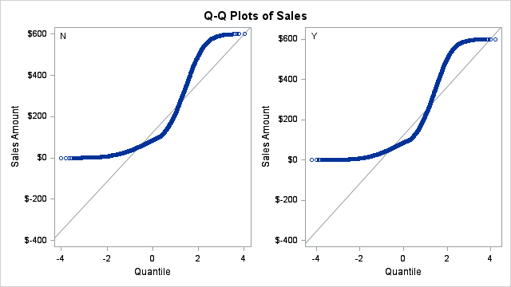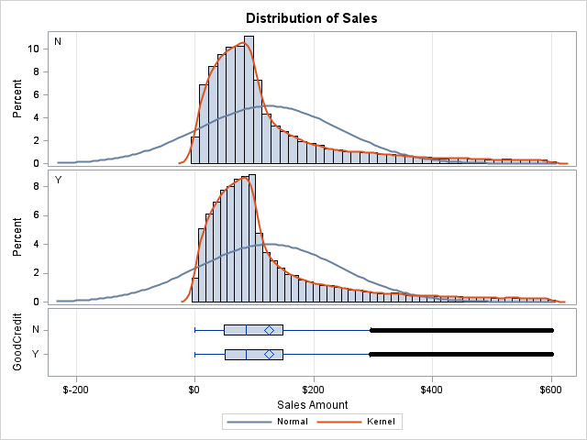

|  |
| --- |
| We can see that with a pvalue of 0.6212, we failed to reject null hypothesis. Thus, the two groups are equal. |

|  |
| --- |
| RELATION BETWEEN SALES AND AGE_SEG |

The MEANS Procedure

|  |  |  |  |  |  |  |  |  |  |  |  |  |  |
| --- | --- | --- | --- | --- | --- | --- | --- | --- | --- | --- | --- | --- | --- |
| Analysis Variable : Sales Sales Amount | | | | | | | | | | | | | |
| AGE_SEG | **N Obs** | **N** | **N Miss** | **Minimum** | **Lower Quartile** | **Median** | **Mean** | **Upper Quartile** | **Maximum** | **Quartile Range** | **Coeff of Variation** | **Lower 95% CL for Mean** | **Upper 95% CL for Mean** |
| <20 years | **1456** | 1456 | 0 | 0.00 | 53.00 | 90.00 | 184.53 | 201.00 | 1195.00 | 148.00 | 128.59 | 172.33 | 196.72 |
| 21 - 40 years | **22757** | 22757 | 0 | 0.00 | 52.00 | 91.00 | 182.09 | 193.00 | 1200.00 | 141.00 | 129.14 | 179.04 | 185.15 |
| 41 - 60 years | **32369** | 32369 | 0 | 0.00 | 53.00 | 92.00 | 181.31 | 189.00 | 1200.00 | 136.00 | 128.93 | 178.77 | 183.86 |
| > 60 years | **20295** | 20295 | 0 | 0.00 | 52.00 | 91.00 | 180.23 | 189.00 | 1200.00 | 137.00 | 128.91 | 177.04 | 183.43 |

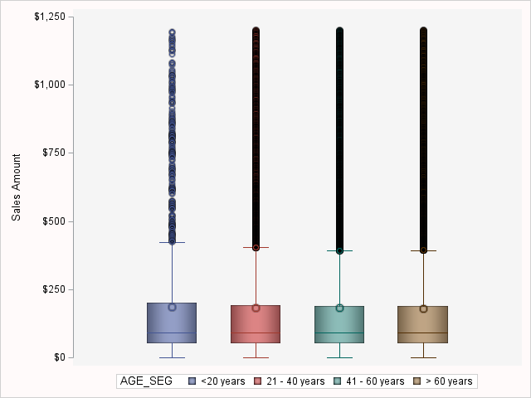

|  |
| --- |
| We can see a great number of major outliers, so as the data is, it's not possible to use t-test for sales and active features. |
| Sales greater than $590 (~Q3+3*IQR) will be dropped to perform the test. |

|  |
| --- |
| RELATION BETWEEN SALES AND AGE_SEG |

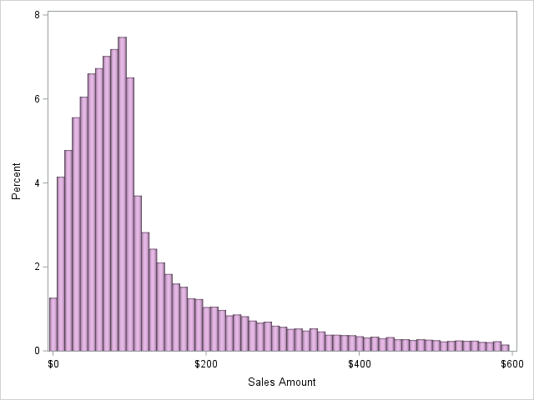The MEANS Procedure

|  |  |  |  |  |  |  |  |  |  |  |  |  |  |
| --- | --- | --- | --- | --- | --- | --- | --- | --- | --- | --- | --- | --- | --- |
| Analysis Variable : Sales Sales Amount | | | | | | | | | | | | | |
| AGE_SEG | **N Obs** | **N** | **N Miss** | **Minimum** | **Lower Quartile** | **Median** | **Mean** | **Upper Quartile** | **Maximum** | **Quartile Range** | **Coeff of Variation** | **Lower 95% CL for Mean** | **Upper 95% CL for Mean** |
| <20 years | **1332** | 1332 | 0 | 0.00 | 49.00 | 83.00 | 122.24 | 153.00 | 576.00 | 104.00 | 94.99 | 116.00 | 128.48 |
| 21 - 40 years | **20969** | 20969 | 0 | 0.00 | 49.00 | 85.00 | 123.87 | 148.00 | 590.00 | 99.00 | 96.26 | 122.26 | 125.49 |
| 41 - 60 years | **29824** | 29824 | 0 | 0.00 | 50.00 | 86.00 | 123.18 | 147.00 | 590.00 | 97.00 | 94.94 | 121.85 | 124.51 |
| > 60 years | **18712** | 18712 | 0 | 0.00 | 49.00 | 85.00 | 122.75 | 147.00 | 590.00 | 98.00 | 95.05 | 121.07 | 124.42 |

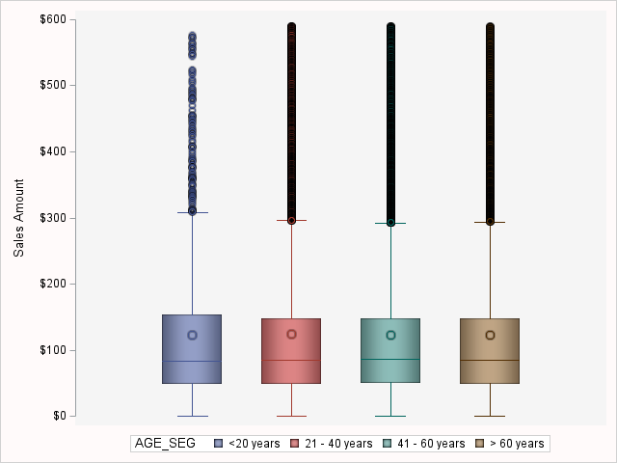

We can see that in each group between active and age features we have more than 100 observations, so there's no need to test for normality.

Let's test for homogeneity of variances:

The GLM Procedure

|  |  |  |
| --- | --- | --- |
| Class Level Information | | |
| Class | **Levels** | **Values** |
| AGE_SEG | 4 | <20 years 21 - 40 years 41 - 60 years > 60 years |

|  |  |
| --- | --- |
| Number of Observations Read | 70837 |
| Number of Observations Used | 70837 |

The GLM Procedure

Dependent Variable: Sales Sales Amount

|  |  |  |  |  |  |
| --- | --- | --- | --- | --- | --- |
| Source | DF | Sum of Squares | Mean Square | F Value | Pr > F |
| Model | 3 | 14420.5 | 4806.8 | 0.35 | 0.7907 |
| Error | 70833 | 978671478.7 | 13816.6 |  |  |
| Corrected Total | 70836 | 978685899.2 |  |  |  |

|  |  |  |  |
| --- | --- | --- | --- |
| R-Square | Coeff Var | Root MSE | Sales Mean |
| 0.000015 | 95.36736 | 117.5440 | 123.2540 |

|  |  |  |  |  |  |
| --- | --- | --- | --- | --- | --- |
| Source | DF | Type I SS | Mean Square | F Value | Pr > F |
| AGE_SEG | 3 | 14420.49490 | 4806.83163 | 0.35 | 0.7907 |

|  |  |  |  |  |  |
| --- | --- | --- | --- | --- | --- |
| Source | DF | Type III SS | Mean Square | F Value | Pr > F |
| AGE_SEG | 3 | 14420.49490 | 4806.83163 | 0.35 | 0.7907 |

The GLM Procedure

|  |  |  |  |  |  |
| --- | --- | --- | --- | --- | --- |
| Levene's Test for Homogeneity of Sales Variance ANOVA of Absolute Deviations from Group Means | | | | | |
| Source | **DF** | **Sum of Squares** | **Mean Square** | **F Value** | **Pr > F** |
| AGE_SEG | 3 | 45955.9 | 15318.6 | 2.30 | 0.0751 |
| Error | 70833 | 4.7163E8 | 6658.3 |  |  |

|  |  |  |  |
| --- | --- | --- | --- |
| Welch's ANOVA for Sales | | | |
| Source | **DF** | **F Value** | **Pr > F** |
| AGE_SEG | 3.0000 | 0.34 | 0.7929 |
| Error | 6356.7 |  |  |

The GLM Procedure

|  |  |  |  |
| --- | --- | --- | --- |
| Level of AGE_SEG | N | Sales | |
| **Mean** | **Std Dev** |
| <20 years | **1332** | 122.242492 | 116.121697 |
| 21 - 40 years | **20969** | 123.874481 | 119.244211 |
| 41 - 60 years | **29824** | 123.181532 | 116.950778 |
| > 60 years | **18712** | 122.746045 | 116.665526 |

|  |
| --- |
| We can see that Levene's test points to equal variances (pvalue of 0.0751), since we fail to reject null hypothesis at 5% significance level. |

The GLM Procedure

|  |  |  |
| --- | --- | --- |
| Class Level Information | | |
| Class | **Levels** | **Values** |
| AGE_SEG | 4 | <20 years 21 - 40 years 41 - 60 years > 60 years |

|  |  |
| --- | --- |
| Number of Observations Read | 70837 |
| Number of Observations Used | 70837 |

The GLM Procedure

Dependent Variable: Sales Sales Amount

|  |  |  |  |  |  |
| --- | --- | --- | --- | --- | --- |
| Source | DF | Sum of Squares | Mean Square | F Value | Pr > F |
| Model | 3 | 14420.5 | 4806.8 | 0.35 | 0.7907 |
| Error | 70833 | 978671478.7 | 13816.6 |  |  |
| Corrected Total | 70836 | 978685899.2 |  |  |  |

|  |  |  |  |
| --- | --- | --- | --- |
| R-Square | Coeff Var | Root MSE | Sales Mean |
| 0.000015 | 95.36736 | 117.5440 | 123.2540 |

|  |  |  |  |  |  |
| --- | --- | --- | --- | --- | --- |
| Source | DF | Type I SS | Mean Square | F Value | Pr > F |
| AGE_SEG | 3 | 14420.49490 | 4806.83163 | 0.35 | 0.7907 |

|  |  |  |  |  |  |
| --- | --- | --- | --- | --- | --- |
| Source | DF | Type III SS | Mean Square | F Value | Pr > F |
| AGE_SEG | 3 | 14420.49490 | 4806.83163 | 0.35 | 0.7907 |

|  |
| --- |
| We can see that with a pvalue of 0.7907, we failed to reject null hypothesis. Thus, the two groups are equal. |

|  |
| --- |
| CONCLUSIONS |

|  |
| --- |
| We can see that from the gathered data, there may be a trend of increase in activations in the beginning of year and in the middle. |
| It seems to be a threshold of 60 days in tenure that either makes customer's leave or stay in a long term relationship.  The NEED reason is the one being most used. |
|  |
| Account Status it's impacted by: |
| Good credit |
| Rate Plan |
| Dealer Type |
| Tenure(Segmented) |
|  |
| Segmented Tenure it's impacted by: |
| Good credit |
| Rate Plan |
| Dealer Type |
|  |
| Sales amount it's not impacted by Account Status, Good credit, or even Age. |

|  |
| --- |
| RECOMMENDATIONS |

|  |
| --- |
| Observe the increasing of deactivations in the last 6 months of 2000 and beginning of 2001. |
| Investigate further the type NEED of deactivations reasons to look for a direct marketing strategy. |
| Investigate further to see the threshold between a finer adjustment the credit score checking would bring benefits. |
| Investigate further Rate Plan 1 for its success with the customers to replicate its features into the other plans. |
| Investigate further Dealer Type A1 for its success with the customers to replicate its features with other dealers. |
| Investigate further the Tenure Segments. |

Next steps: do multivariate analysis(when possible) with the features mentioned above to find other associations.